Week 1 Report Table of Contents

- Chapter 1 ............................................................................................. Page 2
1.1 Ball Forge Plant Orientation Report ……………………………………………. Page 2
- Chapter 2 .............................................................................................. Page 10
2.1 High Chrome Ball Plant Orientation Report ………………………...………… Page 10
- Chapter 3 .............................................................................................. Page 18
3.1 Software Requirements Specifications ………………………………………… Page 18
- Chapter 4 ……………………………………………………………………………………. Page 34
4.1 Introduction to Industrial Automation Report ………………………………. Page 34
- Chapter 5 …………………………………………………………………………………….. Page 44
5.1 Reporting Services Report …………………………………………………………. Page 44
- Chapter 6 …………………………………………………………………………………….. Page 48
6.1 MIS Regression Testing Report …………………………………………………… Page 48
- Chapter 7 …………………………………………………………………………………….. Page 72
7.1 MIS Static Reports ……………………………………………………………………. Page 72

Chapter 1
BALL FORGE PLANT ORIENTATION REPORT

AUTHOR
TSUNDZUKANI NKUNA

Date: 07 / April / 2025
Time: 06: 30 – 17: 00
Last Date: 08 / April / 2025
Time: 05: 30 – 14: 00
CONDUCTOR
SIZWE NHLENGETHWA
Date: 03 / April / 2025
Time: 08: 30 – 10:00
VENUE
BALL FORGE PLANT

Stations
- Ajax 1
- Ajax 2
- Roll Form
- Ball on Ball Tester

Ball Forge Plant Orientation Report Table of Contents

- Introduction ............................................................................................... Page 4
- Grinding Media South Africa Types of Plants ................................................ Page 4
- Ball Forge Plant .......................................................................................... Page 5
3.1 Raw Material ........................................................................................ Page 5
3.2 Final Product ........................................................................................ Page 5
3.3 Raw Material Sourced ........................................................................... Page 5
3.4 Ball Forge Stations ................................................................................ Page 5
- Ajax 1 and Ajax 2 Stations ........................................................................... Page 6
4.1 Ajax 1 and Ajax 2 Ball Forge Process ...................................................... Page 6
4.2 Ajax 1 and Ajax 2 Scale ......................................................................... Page 7
4.3 MCC (Motor Control Circuit) ................................................................ Page 7
- Roll Form Station ...................................................................................... Page 8
5.1 Roll Form Process ............................................................................... Page 8
- Ball on Ball Tester ..................................................................................... Page 9

1. GRINDING MEDIA SOUTH AFRICA


is a South African company whose core business is to manufacture forged grinding balls and high chrome grinding media products for the platinum, gold, ferrochrome, base metals, power generation, and cement industries.
- GMSA is engaged in the design manufacture and distribution of cast and heat-treated high chrome grinding media and heat-treated forged steel balls grinding media for mining, cement and utilities industries.
- Manufacture of grinding balls intended to serve platinum, gold, ferrochrome, base metals, power generation and cement industries.

2. GRINDING MEDIA SOUTH AFRICA CONSIST OF TWO PLANTS

- Ball Forge Plant
- High Chrome Ball Plant

Ball Forge – Refers to forging a spherical metal ball, typically using a harmer or press to shape heated metal into a ball shape.
High Chrome - Refers to a specialized form of cast iron or steel that contains a high percentage of chromium. The high chromium content enhances properties such as hardness, corrosion resistance, and wear resistance.
3. BALL FORGE PLANT
3.1 Raw Materials
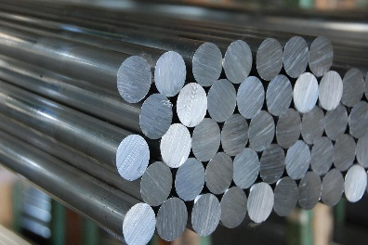
- Round Bars

3.2 Final Product

- Grinding Media

3.3 Raw Materials Source
- Ball Forge Source their raw materials (Round Bars) From Morgan Mill

3.4 Ball Forge Consist Of 4 Stations Namely
- Ajax 1
- Ajax 2
- Roll Form
- BOB (Boll on Boll Tester)

Ajax 1 and Ajax 2 - Use Forge Machine to forge Round Bars as primary product into Grinding Media as Final Product
Roll Form – Use Roll Machine to roll Round Bars as Primary product into Grinding Media as Final Product
BOB – Grinding Medias are placed into a bunker collected by a hook to a certain height to drop 3000 times / 17 hours Cycles to test their Strength and Quality.
4. AJAX 1 AND AJAX 2
- Are stations under Ball Forge Plant that consist of Round Bars as Primary Product.
- Round Bars goes through a forge Process heat up to 12.5 calorimeters to manufacture Grinding Media as Final Product
- Cold Round Bars into Forge Machines can cause serious Break down

4.1 AJAX 1 AND AJAX 2 BALL FORGE PROCESS
- Loading Table – This is the first Process at Ajax 1 and Ajax 2 as Round Bars are loaded into the loading Table.
- Feeder Table – Feeds the Round Bars to the Coil Table.
- Coil Table - Consist of Inductors
- Indictors are controlled by VIPs (Variable Inductive Power)
- Variable Inductive Power – adjust the inductance of a circuit element to control the amount of reactive power.
- Round Bars are heated at 12.5 calorimeter as they pass through the coil Table inductors
- Forge Machine – is an equipment used to produce steel bars, often for use in grinding mills by forging metal into a spherical shape.
- When the round bars are cold through the coil table to the Forge Machine, they might cause serious breakdown.
- Round Bars must be heated first up to 12.5 calorimeter through the inductors for grinding media to be formed.

D.1 TO USE FORGE MACHINE SUCH SHOULD BE PROVIDED

- Water - Frequent water should be provided
- Without Water the plant wont function.
- Electricity
- Grease
- Oil – 20010 liters of drum oil are poured in forge machine and takes 3 days to be renewed / used up.

D.2 HOW TO OPERATE FORGE MACHINE
    - Operating Pannel
    - Isolation – Controls the panel
- Air Cooling Conveyor – From Forge Machine grinding media goes through air cooling elevator or air-cooling conveyor using Natural Air.
- Quinch Tank - Quinch tank Contain Water to pour into quinch drum for cooling process.
- Quinch Drum – Quinch Drum cools grinding media and Harden them using water.
- Furnace – Heat Treatment such as Quenching
- Stress Relieving
- Hardening
- Bunkers – Stores Final Products Grinding Media.
- Grinding Media are packaged in bags or drums.

4.2 Ajax 1 and Ajax 2 Scale
- Primary Scale and Secondary Scale
- MIS Systems – Active Delay System

- Control Systems – Wonderware SCADA System

4.3 MOTOR CONTROL CIRCUIT
- Consist of PLC (Programming Logic Controller)
- Consist of HMI (Human Machine Interface)
- Consist of Drivers

Programming Logic Controller | Human Machine Interface | Drivers
- Control the whole plant | - Motors are connected to the HMI | - Drivers has Him
- Set speed of motors | - Elevators are connected to the HMI | - Hi - Frequency
- Set temperature |  | - Amps - Current
- Control VIPs (Variable Inductive Power) |  | - Bus VDC – Direct Current Voltage

5. ROLL FORM
- Uses a continuous process to shape metals such as steels, stainless steel and solid non-ferrous metals such as nickel, titanium and copper.
- The process uses consecutive sets of matted rolls, each of which makes only incremental changes in the form
- involves using a series of rollers to incrementally bend a long strip of metal into a desired shape.
- Each set of rollers performs a small part of bending, with the cumulative effect creating the final shape.

5.1 ROLL – FORM PROCESS
- Loading Table – This is the first process at Roll Form as Round Bars are loaded into the loading Table.
- Feeder Table – Feeds the Round Bars to the Coil Table.
- Coil Table - Consist of Inductors
- Indictors are controlled by VIPs (Variable Inductive Power)
- Variable Inductive Power – adjust the inductance of a circuit element to control the amount of reactive power.
- Round Bars are heated at 12.5 calorimeter as they pass through the coil Table inductors
- Round Bars are driven slowly in coil tables to accumulate as much heat needed for desired final products grinding medias to be formed.
- Rolls - They cut Round Bars into desired shapes to form Grinding Media
- Air Cooling Conveyor - From Forge Machine grinding media goes through air cooling elevator or air-cooling conveyor using Natural Air.
- Quinch Drum – Quinch Drum cools grinding media and Harden them using water.
- Cooling Box – Temperature must be set.
- Use Cold Room Temperature to Cool Grinding Media
- Furnace – Heat Treatment such as Quenching
- Stress Relieving
- Hardening
- Bunkers – Stores Final Products Grinding Media.
- Grinding Media are packaged in bags or drums.

6. BOB
Ball on Ball Test
- From Bunkers Certain amount of Grinding Medias are collected to Ball-on-Ball Tester to test the quality and strength.
- Grinding Medias are collected by hook to certain height to drop them 3000 times / 17 hours
- Failure – if more than 6 Grinding media cracks the whole batch must be scrapped.
- Scrapped Batch is taken to High Chrome Ball Plant Furnace for melting.

Chapter 2
HIGH CHROME BALL PLANT ORIENTATION REPORT

AUTHOR
TSUNDZUKANI NKUNA

Date: 08 / April / 2025
Time: 08: 20 – 17: 00
Last Date: 09 / April / 2025
Time: 05: 30 – 07: 00
CONDUCTOR
SIZWE NHLENGETHWA
Date: 04 / April / 2025
Time: 09: 40 – 10:00
Last Date: 07 / April / 2025
Time: 08: 30 – 11: 00

VENUE
HIGH CHROME BALL PLANT
Stations
- Line 1
- Line 2
- Line 3
High Chrome Ball Plant Orientation Report Table of Contents

- Introduction .............................................................................................. Page 12
- Grinding Media South Africa Types of Plants ............................................... Page 12
3. High Chrome Ball Plant ............................................................................. Page 13
3.1 Raw Material ....................................................................................... Page 13
3.2 Scrap Material ..................................................................................... Page 13
3.3 Final Product ....................................................................................... Page 13
3.3 Raw Material and Scrap Sourced .......................................................... Page 13
3.4 HCBP Stations ..................................................................................... Page 13
4. Weigh Bridge .............................................................................................. Page 14
4.1 Weigh Bridge Purpose at HCBP ............................................................... Page 14
5.Department Of Charge Preparation ............................................................. Page 14
- Furnace .................................................................................................... Page 15
6.1 Two Types of furnaces ......................................................................... Page 15
6.1.1 Arc Furnace (15 Ton Induction Furnace) ......................................... Page 15
6.1.2 Electrical Induction Furnace ......................................................... Page 15
6.1.2.1 Different Induction Furnace Unit ........................................... Page 15
- Line 1 Control Room ................................................................................. Page 16
7.1 MIS System found in line 1 control room .............................................. Page 16
7.2 Vibre Drums ....................................................................................... Page 16
7.3 Seperator Machine ............................................................................. Page 16
7.4 Furnace ............................................................................................. Page 16
7.5 Air Cooling Conveyor .......................................................................... Page 17
7.6 Quinche Tank ..................................................................................... Page 17
7.7 Filling Drum Station ............................................................................ Page 17
- Line 2 and Line 3 Control Room ................................................................. Page 17
8.1 Line 1, Line 2 and Line 3 Differences .................................................... Page 17
8.1.1 Shaker Drum ............................................................................. Page 17
- High Chrome Ball Plant Laboratory ........................................................... Page 17

1. GRINDING MEDIA SOUTH AFRICA

is a South African company whose core business is to manufacture forged grinding balls and high chrome grinding media products for the platinum, gold, ferrochrome, base metals, power generation, and cement industries.
- GMSA is engaged in the design manufacture and distribution of cast and heat-treated high chrome grinding media and heat-treated forged steel balls grinding media for mining, cement and utilities industries.
- Manufacture of grinding balls intended to serve platinum, gold, ferrochrome, base metals, power generation and cement industries.

2. GRINDING MEDIA SOUTH AFRICA CONSIST OF TWO PLANTS

- Ball Forge Plant
- High Chrome Ball Plant

Ball Forge – Refers to forging a spherical metal ball, typically using a harmer or press to shape heated metal into a ball shape.
High Chrome - Refers to a specialized form of cast iron or steel that contains a high percentage of chromium. The high chromium content enhances properties such as hardness, corrosion resistance, and wear resistance.

3. HIGH CHROME BALL PLANT
3.1 Raw Materials
- Anthracite
- Ferro Chrome
- Burnt Lime
- Types of Chrome Grades
- E12
- E18
- E27
- E50
- IC3 CR
- Rivets E50
3.2 Scrap Materials
- Electro Platin Scrap
- Induction Furnace
- Stainless Steel

3.3 Final Product
- Grinding Media

3.4 Raw Materials and Scrapped Sourced
- High Chrome Ball Plant Source their raw materials and scrap materials from suppliers

3.5 High Chrome Ball Plant Consist Of 3 Stations Namely
- Line 1
- Line 2
- Line 3

4. WEIGH BRIDGE
- It is a large set of scales used to weigh entire vehicles and their contents, typically mounted on a concrete foundation. They are used to ensure compliance with weight limits, track shipments, and improve efficiency in various industries.

4.1 Weigh Bridge Purpose at High Chrome Ball Plant
- Check Types of Scrap
- Check if Scrap Contains any harmful Substance
- Check Quality of Scrap
- Check Scrap weigh

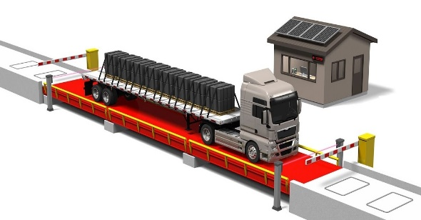

5. DEPARTMENT OF CHARGE PREPARATION
- They are responsible for mixing the amount of scrap and alloys as recipes to get determined final product Grinding Media.
- Certain Amount and Type of Scrap from Scrap Bunkers are collected and placed inside a Charge Bucket.
- The determined amount of alloy and type of alloy is carried by an underground trolley travelling through rail lines and is dropped inside a charge bucket.
- The Charge Preparation Department calculates the amount and type of alloy to be mixed with scrap in a charge bucket. This is how a recipe is determined on what to melt for that certain day.
- Determined Recipe should consist of Scraps from Scarp Bunkers and Alloys from alloys bunkers with clear calculations and mixed inside a charge bucket.
- Charge Bucket mixes and carry final mixed Raw Materials.
- From Charge Bucket Final Mixed Raw Materials are transported through conveyors to a Furnace for melting

6. FURNACE
- An enclosed structure in which material can be heated to very high temperatures, e.g. for melting metals.
- Mixed raw materials from Charge Bucket are Poured into a furnace for melting.
- Certain Scrap Materials that can't be Melt at Electrical Furnace are melt at Arch Furnace.
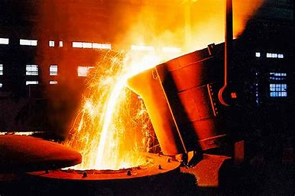
6.1 TWO TYPES OF FURNACES
6.1.1 Arch Furnace (15 Ton Induction Furnace)
- These are cylindrical furnaces in which an arc is formed between the carbon electrodes (from the top) and hearth electrodes. The hearth lining is of magnesite which becomes comparatively good electrical conductor when hot
- Arc Furnace melt raw materials using electrodes.

6.1.2 Electrical Induction Furnace
- is an electrical furnace in which the heat is applied by induction heating of metal
- Certain Scrap Materials that can't be melted at arc furnaces are melted at Electrical Induction Furnace.

6.1.2.1 Different Electrical Induction Furnace Units
- UNIT A
- UNIT B
- UNIT C

7. LINE 1 CONTROL ROOM
- All melted raw materials from Furnaces are sent either to line 1, line 2 or line 3.
- In Line 1 all melted metals from furnace go into press pour (Pressurized pouring Unit)
- Disa Machine - melted metals from press pour travel though a conveyor to Disa Machine
- Disa Machine form molds using melted metals and sand
7.1 MIS SYSTEMS FOUND IN LINE 1 CONTROL ROOM
- Active Delay System - measures the delay of melting balls.
- Chemistry Analysis System – measures the samples from furnaces and press pour.
- Induction Furnace Report System – measures production report
- Measures active delay report
- measures assigned delays report
- measures unassigned delays report.
- Sand Control System – Check plant performance
- Display the pouring temperature of the pressurized pouring unit.
- Display the time and amount of sand that is coming in the line.
7.2 VIBRE DRUM
- From Disa Machine Formed Molds / Final Product will consist of sand.
- Final Product with sand travel though a conveyor to vibre drum for sand to be removed
7.3 SEPERATOR MACHINE
- Separator machine separate grinding media from reverts
7.4 FURNACE
- Heat Treatment
- Quenching
- Stress Relieving
- Hardening
- Theys use fire to increase mechanical strength of grinding media

7.5 AIR COOLING CONVEYOR
- From Furnace heat treatment grinding media goes to quinch tank through air cooling conveyor being cooled down using Natural Air.
7.6 QUINCH TANK
- Cools down grinding media using processed oil
7.7 FILLING DRUM STATION
- From quinch tank grinding media are taken to filling drums
- Final products are collected by trucks from bags or drums

8. LINE 2 AND LINE 3 CONTROL ROOM
- Same raw materials and scrap materials that go to line 1 also can go to line 2 and line 3
- Same process that line 1 uses to produce final product Grinding media applies on line 2 and line 3
- The only difference is, and equipment found in between vibre drum and separator machine that is only used in line 2 and line 2
8.1 LINE 1, LINE 2 AND LINE 3 DIFFERENCES
8.1.1 SHAKER DRUM
- The only equipment that differentiates the process of how grinding media are made from line 1 to line 2 and line 3 is a shaker drum.
- Shaker drums are found in between vibre drum and Separator drum. As in line 1 in between there's no shaker drum grinding media are conveyed from vibre drum to Separator drum.
- A shaker drum its function is to split the grinding media apart.
9. HIGH CHROME BALL PLANT LABORATORY
- Spectro lab
- Analyze samples from furnace using Spectrometer Machine.
- On the graph if the internal spec is outside the NGM it's a scrap
- Decision if melted metal is a scrap must be taken by metallurgist either re – melt or sell as scrap.

Chapter 3
PERSONA

TSUNDZUKANI NKUNA
MIS Automation Technician Trainee

“Successful projects are usually the results of careful planning and the talent, and collaboration of a project team”.
Facts | Behaviors
- Age 27 | - Hard Worker
- MIS Automation Technician Trainee | - Organized
- Enjoys Nature and the Outdoors | - Passionate
- Enjoys Changaan Music /Xigaza Music | - Likes things neat and tidy
- Interested in continuous learning and upskilling in tech | - Enjoy a structured routine
- Holds a diploma in Information Technology (Software Development) | - Passionate about problem-solving and process improvement

Needs and Goals

- Improve the Chemistry Analysis System
- Update/Improve Chemical Information platform for Operators who are struggling to read analyzed information
- To have a way to easily communicate with operators
- To create a reliable environment for Control rooms operators
- Foster collaboration between technicians, engineers, and operators
- Translate complex Information into understandable summaries for frontline staff
- Improve real-time Information visualization for quicker decision-making

SRS DOCUMENT TABLE OF CONTENT
- SRS (Software Requirement Document) .................................................... Page 20
1.1 Purpose ……………………………………………………………………………………. Page 20
1.2 Scope ………………………………………………………………………………………. Page 20
- Overall Description …................................................................................ Page 21
2.1 Product Perspective ............................................................................ Page 21
2.2 Product Features ................................................................................ Page 21
2.3 User Characteristics ........................................................................... Page 22
2.3 Constraints ........................................................................................ Page 22
2.4 Non-Functional Requirements ............................................................ Page 22
- Use Cases ............................................................................................... Page 23
3.1 Use Cases Figure ............................................................................... Page 23
- Use Cases Specifications …………............................................................. Page 24
4.1 UC-1 ………………………………………………………………………………………… Page 24
4.2 UC-3 ………………………………………………………………………………………… Page 25
4.4 UC-4 ………………………………………………………………………………………… Page 26
4.5 UC-5 ………………………………………………………………………………………… Page 27
4.6 UC-6 ………………………………………………………………………………………… Page 28
- Use Cases in WBS Diagram ..................................................................... Page 29
5.1 Operator View Line 1 Information ...................................................... Page 29
5.2 Operator View Line 2 Information ...................................................... Page 30
5.3 Operator View Line 3 Information ...................................................... Page 31
5.4 Operator View Bath Plotting samplers Charts .................................... Page 32
5.5 Operator View Pit Plotting samplers Charts ....................................... Page 32
- Database Erds ........................................................................................ Page 33
6.1 Erd Figure ………………………………….................................................... Page 33
1. SRS DOCUMENT
(Software Requirements Specification)
1.1. Purpose
- The purpose of the Chemical Analysis System under the High Chrome Ball Plant is to automate the process of storing, retrieving, analyzing, and displaying chemical analysis information. The system is designed to simplify and improve communication between Operators, Technicians, Engineers, and Metallurgists by providing accurate and timely insights into the chemical composition of Molds extracted from the furnace.
- By streamlining access to analyzed chemical information, the system supports better decision-making, enhances process control, and promotes efficiency in the handling and monitoring of high chrome ball production quality.

1.2. Scope
The Chemical Analysis System is developed to support the High Chrome Ball Plant by automating the workflow related to chemical data management. The system will:
- Connect to a centralized database to store and retrieve chemical analysis results from Molds extracted from the furnace.
- Allow Operators, Technicians, and Engineers to easily access and interpret chemical Information related to production.
- Provide a platform for Metallurgists to review, verify, and provide feedback on the chemical composition of Molds.
- Automatically display information in a user-friendly format, reducing reliance on manual reports or spreadsheet tracking.
- Ensure efficient communication and collaboration between production and quality control teams through real-time information access.
- Offer the ability to track historical information, Charts trends, and performance for quality assurance and process optimization.
The system focuses on Line 1, Line 2, Line 3, Bath Plotting Samples and Pit Plotting Samples chemical analysis, but may be scaled or adapted for additional lines or plants in the future.

2. Overall Description
2.1 Product Perspective
The Chemical Analysis System is a standalone application that will integrate with the existing operational environment of the High Chrome Ball Plant. It will be designed to support and enhance the chemical analysis process of extracted Molds from the furnace, particularly those recorded under Line 1, Line 2 and Line 3.
The system will act as a bridge between production-level personnel (Operators, Technicians, Engineers) and quality control experts (Metallurgists), enabling real-time access to chemical composition information and promoting effective communication and decision-making.
The system will use a user-friendly interface to present analyzed results in a structured table format, with features that include:
- Retrieval and display of recent chemical analysis information.
- Error handling for empty or missing datasets.
- Display of the latest readings per sample, including critical elements (e.g., Fe, Cr, C, Mn, etc.).
2.2 Product Features
2.2.1 Database Connectivity
- Connects to a SQL Server database to retrieve and store chemical analysis information.
- Use secure connection strings and handles connectivity errors.
2.2.2 Chemical information Retrieval
- Execute SQL queries to fetch recent chemical analysis results from Line 1, Line 2 and Line 3 table.
- Supports filtering by date range or cast number (optional future enhancement).
2.2.3 User-Friendly Data Display
- Presents chemical analysis results in a clear table/grid format on the user interface.
- Displays key attributes such as Date, Time, Cast No, Source, Grade, and elemental composition (e.g., Fe, Cr, Mn, C).
- Display Pit Plotting Samples / Bath Plotting Samples in Chart Format
2.2.4 Latest Result Indicators
- Highlights the most recent Operator, Grade, Source, and Cast No from the information set.
- Useful for quick status checking by engineers and metallurgists.
2.2.5 Communication Support
- Facilitates better collaboration between Operators, Technicians, Engineers, and Metallurgists by centralizing access to analysis data.
- Serves as an informal platform for referencing recent chemical trends during decision-making.

2.3 User Characteristics
The system will be used by:
- Operators: Individuals responsible for reviewing and analyzing chemical information.
- Technicians/Engineers: Users who will manage the information and ensure the system operates smoothly.
2.4 Constraints
- The system will need to be connected to an SQL database.
- The database table structure should match the required format for the data.
- The application should be able to handle errors (e.g., when data is missing, or if a table doesn't exist).

2.5 Non-Functional Requirements
2.5.1 Performance Requirements
  - The system should be able to load data from the database within a few seconds.
  - The table should be displayed quickly after data retrieval.
2.5.2 Security Requirements
  - The system will use secure database credentials.
  - Only authorized users will have access to sensitive data.

2.5.3 Usability Requirements
  - The interface should be simple, intuitive, and easy to navigate.
  - Users should be able to easily view and understand the data displayed.

3. USE CASES

3.1 Use Cases Figure
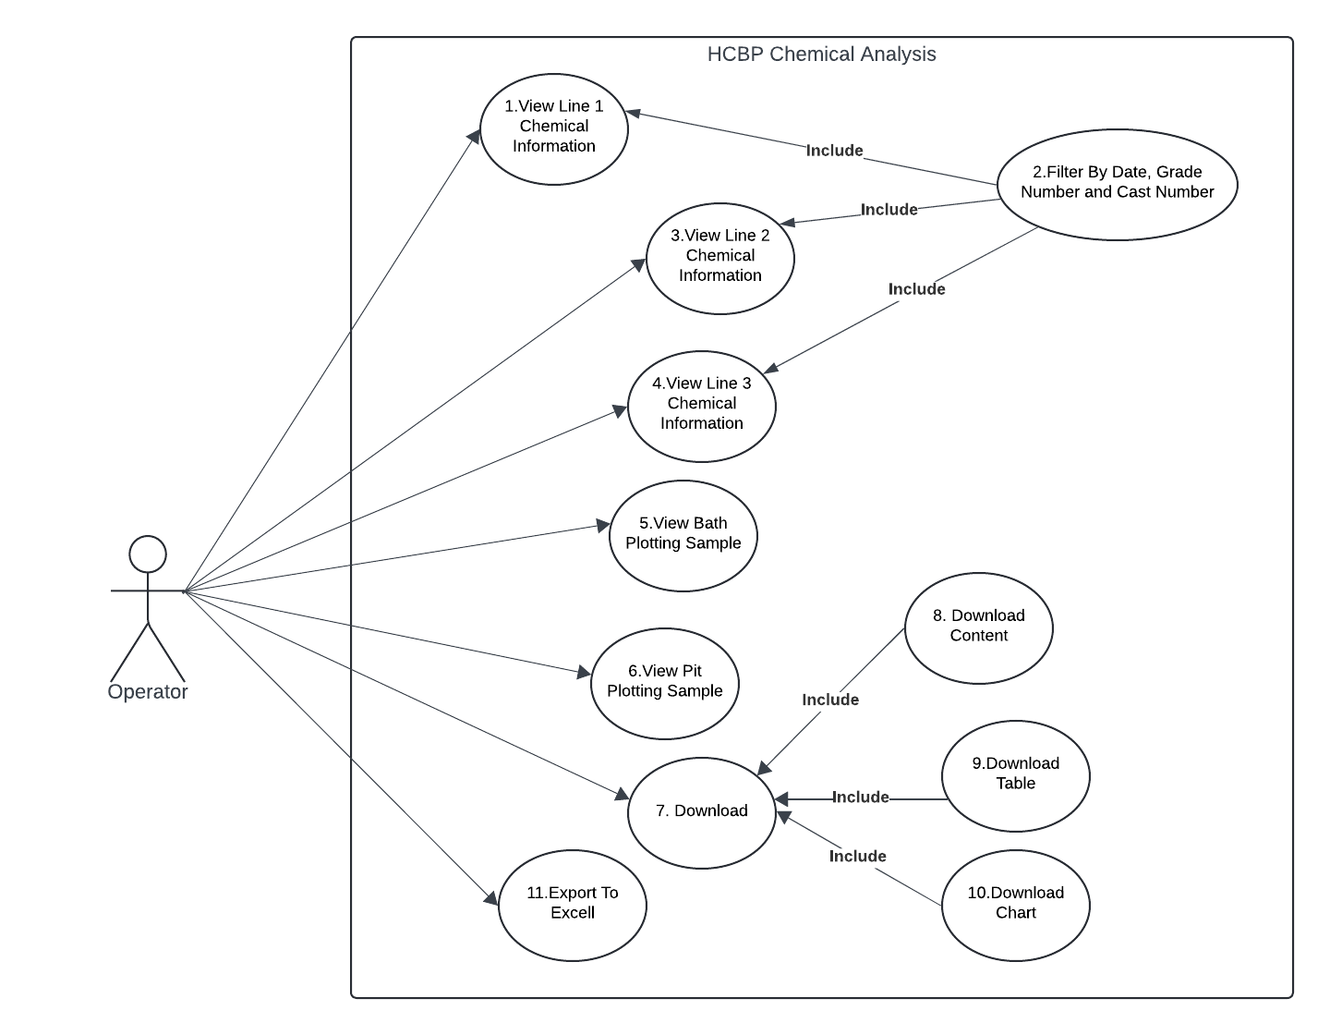
4. USE CASES SPECIFICATION
4.1 UC-1
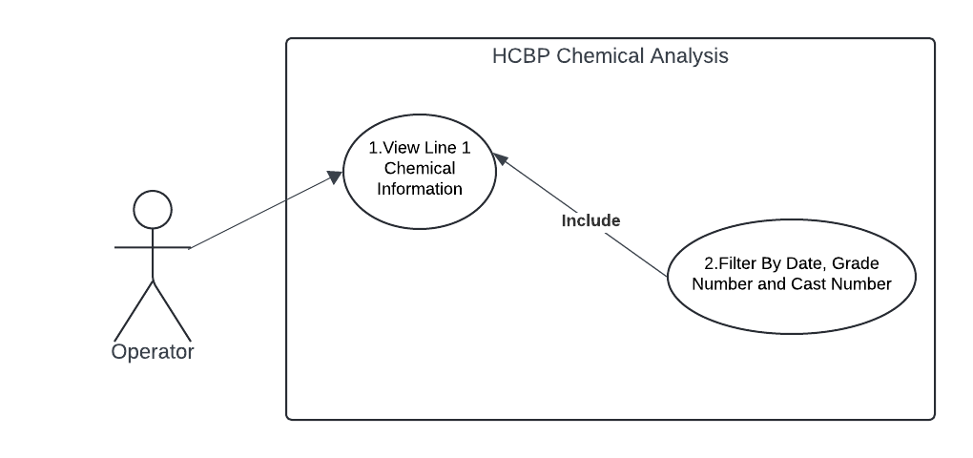
Use Case: short active verb
Use Case ID | UC - 1
Use Case Name | View Line 1 Chemical Analysis
Actor(s) | Operator, Technician, Engineer, Metallurgist
Description | The system retrieves and displays recent chemical analysis data from the Line1 table in a tabular format for user review.
Precondition | - The system is connected to the SQL database.  - Line1 table exists.  - The table contains at least one data record.
Post-condition | - Data is successfully displayed to the user in a readable table
Alternate Flow | - If the table is empty, the system displays a message: "No data found."  - If the table does not exist, a fallback message or exception is triggered.
Exceptions
  - Database connection fails.
  - Table not found.
  - Data retrieval times out.
Main flow of events | Step | User action | System response
 | 1. | User navigates to the Line 1 view page | Mouse Pointer point to Line1 link
 | 2. | Use Clicks on Line 1 Link | System executes SQL query to retrieve the latest chemical information.
 | 3. |  | information is formatted into a table and displayed on screen.

4.2 UC-3
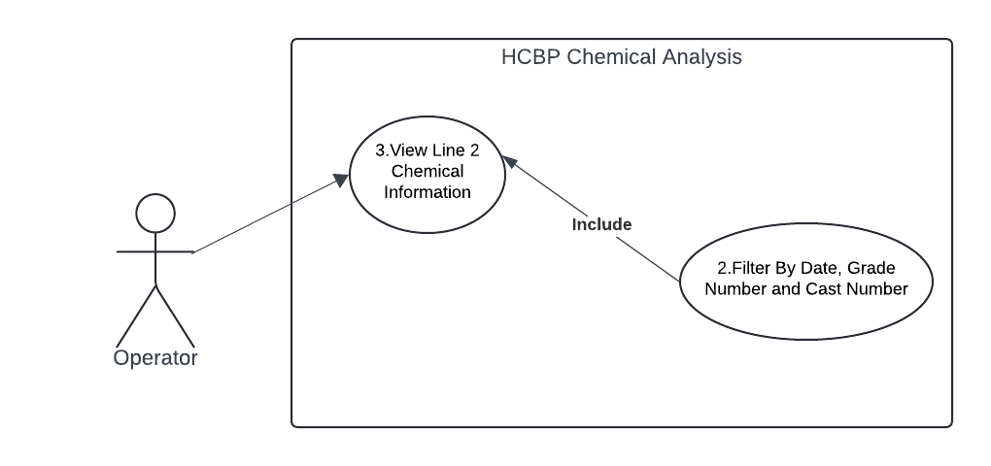
Use Case: short active verb
Use Case ID | UC - 2
Use Case Name | View Line 2 Chemical Analysis
Actor(s) | Operator, Technician, Engineer, Metallurgist
Description | The system retrieves and displays recent chemical analysis data from the Line2 table in a tabular format for user review.
Precondition | - The system is connected to the SQL database.  - The Line2 table exists.  - The table contains at least one data record.
Post-condition | - Data is successfully displayed to the user in a readable table
Alternate Flow | - If the table is empty, the system displays a message: "No data found."  - If the table does not exist, a fallback message or exception is triggered.
Exceptions
  - Database connection fails.
  - Table not found.
  - Data retrieval times out.
Main flow of events | Step | User action | System response
 | 1. | User navigates to the Line 2 view page | Mouse Pointer point to Line2 link
 | 2. | Use Clicks on Line 2 Link | System executes SQL query to retrieve the latest chemical information.
 | 3. |  | information is formatted into a table and displayed on screen.

4.3 UC-4
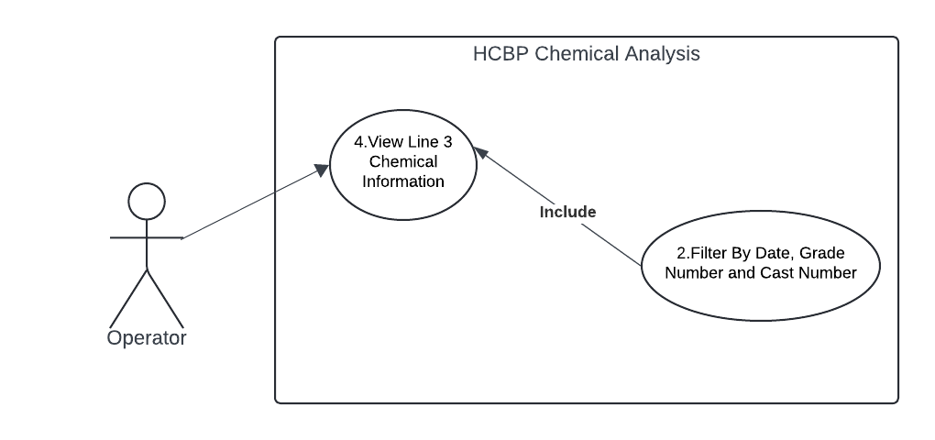
Use Case: short active verb
Use Case ID | UC - 4
Use Case Name | View Line 3 Chemical Analysis
Actor(s) | Operator, Technician, Engineer, Metallurgist
Description | The system retrieves and displays recent chemical analysis data from the Line2 table in a tabular format for user review.
Precondition | - The system is connected to the SQL database.  - The Line3 table exists.  - The table contains at least one data record.
Post-condition | - Data is successfully displayed to the user in a readable table
Alternate Flow | - If the table is empty, the system displays a message: "No data found."  - If the table does not exist, a fallback message or exception is triggered.
Exceptions
  - Database connection fails.
  - Table not found.
  - Data retrieval times out.
Main flow of events | Step | User action | System response
 | 1. | User navigates to the Line 3 view page | Mouse Pointer point to Line3 link
 | 2. | Use Clicks on Line 3 Link | System executes SQL query to retrieve the latest chemical information.
 | 3. |  | information is formatted into a table and displayed on screen.

4.4 UC-5
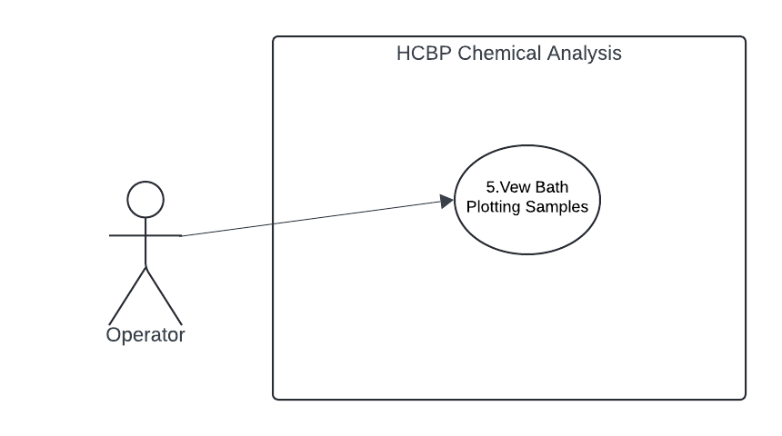
Use Case: short active verb
Use Case ID | UC - 5
Use Case Name | View Bath Plotting Samples
Actor(s) | Operator, Technician, Engineer, Metallurgist
Description | The system retrieves and displays recent chemical analysis information from the Bath Plotting Samples table in a Chart and tabular format for user review.
Precondition | - The system is connected to the SQL database.  - The Bath Plotting Samples table exists.  - The table contains at least one Information record.
Post-condition | - Information is successfully displayed to the user in a readable Charts
Alternate Flow | - If the table is empty, the system displays a message: "No Information found."  - If the table does not exist, a fallback message or exception is triggered.
Exceptions
  - Database connection fails.
  - Table not found.
  - Information retrieval times out.
Main flow of events | Step | User action | System response
 | 1. | User navigates to the Bath Plotting Samples Link | Mouse Pointer point to Bath Plotting Sample link
 | 2. | Use Clicks on Bath Plotting Sample Link | System executes SQL query to retrieve the latest chemical information.
 | 3. |  | information is formatted into a Chart and displayed on screen.

4.5 UC - 6
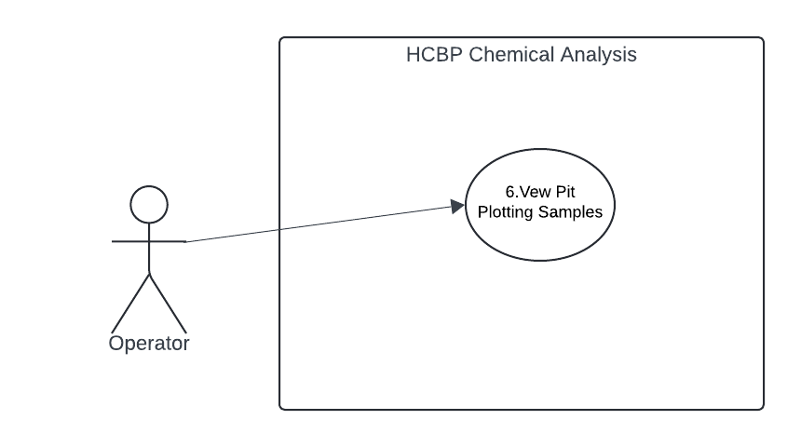
Use Case: short active verb
Use Case ID | UC - 6
Use Case Name | View Pit Plotting Samples
Actor(s) | Operator, Technician, Engineer, Metallurgist
Description | The system retrieves and displays recent chemical analysis information from the Pit Plotting Samples table in a Chart and tabular format for user review.
Precondition | - The system is connected to the SQL database.  - The Pit Plotting Samples table exists.  - The table contains at least one Information record.
Post-condition | - Information is successfully displayed to the user in a readable Charts
Alternate Flow | - If the table is empty, the system displays a message: "No Information found."  - If the table does not exist, a fallback message or exception is triggered.
Exceptions
  - Database connection fails.
  - Table not found.
  - Information retrieval times out.
Main flow of events | Step | User action | System response
 | 1. | User navigates to the Pit Plotting Samples Link | Mouse Pointer point to Pit Plotting Sample link
 | 2. | Use Clicks on Pit Plotting Sample Link | System executes SQL query to retrieve the latest chemical information.
 | 3. |  | information is formatted into a Chart and displayed on screen.

5. USE CASES IN WBS DIAGRAM
5.1. Operator View Line 1 Information
|
IF (Data! = Null)
5.1.1 Display Line 1 Current Operator
5.1.2 Display Line 1 Grades
5.1.3 Display Line 1 Total Pit and Bath Samples for the day
5.1.4 Filter Line 1 Information
5.1.4.1 Filter by Date
5.1.4.2 Filter by Time
5.1.4.3 Filter by Grade Number
5.1.4.4 Filter by Cast Number
5.1.5 Download
5.1.5.1 Download Page Content
5.1.5.2 Download Table Data
5.1.6 Export to Excell
5.1.6.1 Export Table Data to Excel
|
ELSE
{“Console No Line 1 Information Available for Display”}

5.2. Operator View Line 2 Information
|
IF (Data! = Null)
5.2.1 Display Line 2 Current Operator
5.2.2 Display Line 2 Grades
5.2.3 Display Line 2 Total Pit and Bath Samples for the day
5.2.4 Filter Line 2 Information
5.2.4.1 Filter by Date
5.2.4.2 Filter by Time
5.2.4.3 Filter by Grade Number
5.2.4.4 Filter by Cast Number
5.2.5 Download
5.2.5.1 Download Page Content
5.2.5.2 Download Table Data
5.2.6 Export to Excell
5.2.6.1 Export Table Data to Excel
|
ELSE
{“Console No Line 2 Information Available for Display”}

5.3. Operator View Line 3 Information
|
IF (Data! = Null)
5.3.1 Display Line 3 Current Operator
5.3.2 Display Line 3 Grades
5.3.3 Display Line 3 Total Pit and Bath Samples for the day
5.3.4 Filter Line 2 Information
5.3.4.1 Filter by Date
5.3.4.2 Filter by Time
5.3.4.3 Filter by Grade Number
5.3.4.4 Filter by Cast Number
5.3.5 Download
5.3.5.1 Download Page Content
5.3.5.2 Download Table Data
5.3.6 Export to Excell
5.3.6.1 Export Table Data to Excel
|
ELSE
{“Console No Line 3 Information Available for Display”}

5.4. Operator View Bath Plotting Samples Chart
IF (Data! = Null)
5.4.1 Display Bath Plotting Samples in Chart
5.4.1.1 Filter by Date
5.4.1.2 Filter by Line 1, Line 2 and Line 3
5.4.1.3 Filter by Grade Number
5.4.2 Download
5.4.2.1 Download Page Content
5.4.2.2 Download Bath Plotting Chart
5.4.3 Export to Excell
|
ELSE
{“Console No Bath Plotting Chart Samples Information Available for Display”}

5.5. Operator View Pit Plotting Samples Charts
IF (Data! = Null)
5.5.1 Display Pit Plotting Samples in Chart
5.5.1.1 Filter by Date
5.5.1.2 Filter by Line 1, Line 2 and Line 3
5.5.1.3 Filter by Grade Number
5.5.2 Download
5.5.1 Download Page Content
5.5.2 Download Pit Plotting Chart
5.5.3 Export to Excell
|
ELSE
{“Console No Pit Plotting Chart Samples Information Available for Display”}
6. DATABASE ERDs
6.1 Erd Figure
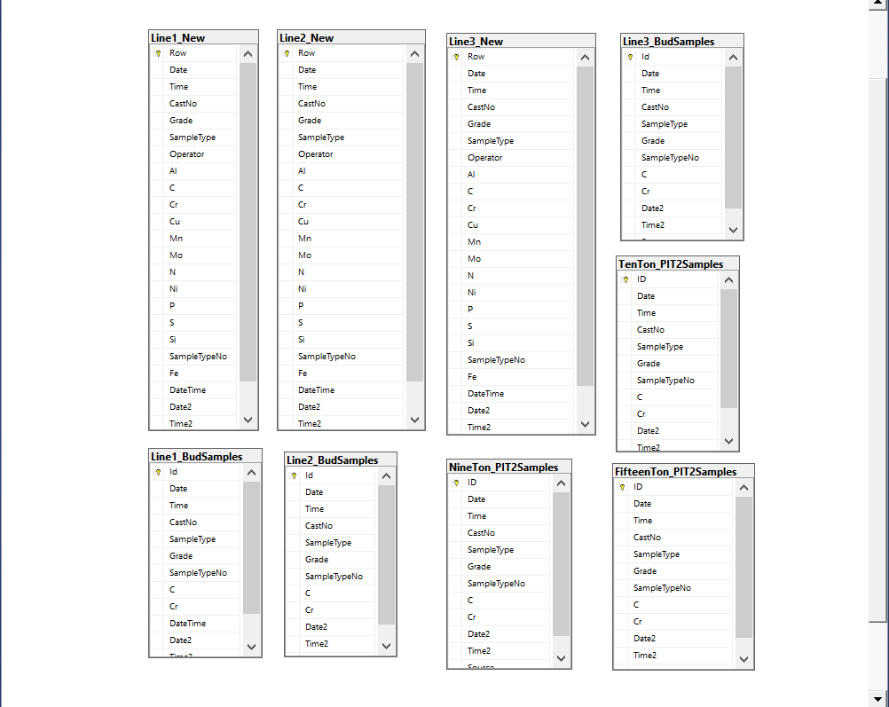

Chapter 4
INTRODUCTION TO INDUSTRIAL AUTOMATION REPORT

AUTHOR
TSUNDZUKANI NKUNA

Date: 10 / April / 2025
Time: 12: 03 – 16: 00
Mentor 1: Sizwe Nhlengethwa
Mentor 2: Bhekabona Mbhele

INTRODUCTION TO AUTOMATION TABLE OF CONTENT

- Introduction to Industrial Automation ....................................................… Page 36
  - Understanding Software Engineering ……………………………………………. Page 36
    - Software Development Life Cycle ….……………………………………. Page 36
    - Software Development Methodology …………………………………… Page 37
  - Introduction to GMSA’s MIS Set Ups………………………………………………. Page 38
    - SQL Server Reporting Server…………………………………………….…. Page 38
    - Historian …………………………………………………………………………. Page 38
    - Processing Text Files …………………………………………………….….. Page 39
  - Understanding OT ……………………………………………………………………… Page 39
    - Virtual Local Area Network …………………………………………….….. Page 39
    - IT UJ Network …………………………………………………………………… Page 40
  - Understanding Industrial Automation Technology ………………………….. Page 40
4.4.1 Types of Industrial Automation Systems ……………………………….. Page 40
  - Understanding MIS and MES ……………………………………………………….. Page 41
4.5.1 Management Information System ………………………………………… Page 41
4.5.2 Management Execution System …………………………………………… Page 41
  - Understanding OSI Model Levels ………………………………………………….. Page 42
4.6.1 The Osi Model ……………………………………………………………………. Page 42
  - The MIS Job Specifications ………………………………………………………….. Page 43
4.7.1 MIS Specialist Key Responsibilities ……………………………………….. Page 43

4. Introduction To Industrial Automation
4.1 Understanding Software Engineering: Best practices of applications development
- Software development is the process of designing, writing, testing, and maintaining software applications. It involves working with programming languages, frameworks, and tools to create software that meets specific requirements and solves user problems.
- Software engineering encompasses software development, engineering principles, techniques, and best practices to the entire software production process. such as software architecture, design patterns, quality assurance, project management, and systems integration.

4.1.1 Software Development Life Cycle
An approach or set of practices used by a team to develop a product STEPS / STAGES
- Requirements Gathering
- Prototyping
- Design
- Coding
- Testing
- Deployment
- Maintenance
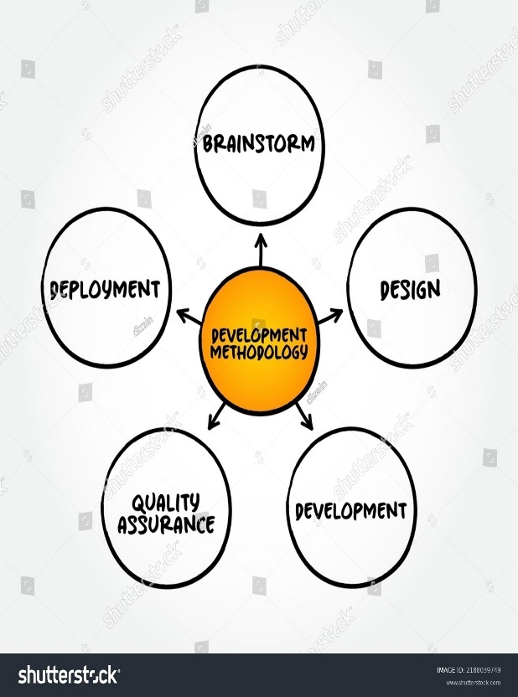

4.1.2 Software Development Methodology
It is a particular design philosophy in which it helps the software developers to align these processes and the features of the software product
- Agile Methodology - is a project management framework that breaks projects down into several dynamic phase, known as sprints
- Scrum Methodology - is an agile framework for team collaboration and problem solving
- Waterfall Methodology - follows a linear and sequential process where each phase must be completed before moving on to the next
- Rapid Application Development - emphasizes quick and iterative release cycles, focusing on delivering working software in shorter timelines

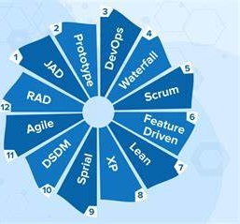

4.2 Introduction to GMSA’s MIS set-up (SSRS reports, Historian, processing text files)
4.2.1 SQL Server Reporting Service
- It is one of the popular Business intelligence tools
- Is a comprehensive set of tools and services provided by Microsoft to create, deploy, and manage paginated reports
- Paginated reports are ideal for fixed-layout documents optimized for printing, such as PDFs and Word files
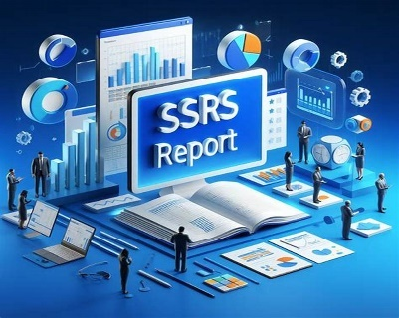

4.2.2 HISTORIAN
Wonderware Historian is a high-performance process historian that captures and stores vast amounts of data generated by industrial control systems like:
- SCADA (Supervisory Control and Data Acquisition)
- PLCs (Programmable Logic Controllers)
- DCS (Distributed Control Systems)
- HMI (Human Machine Interfaces)


4.2.3 Processing Text Files
- The process of transforming text data based on specific applications, methods, and evaluations.
- The primary goal of text processing is to transform raw textual content into structured, machine-readable formats that can be analyzed, summarized, or utilized for decision-making.
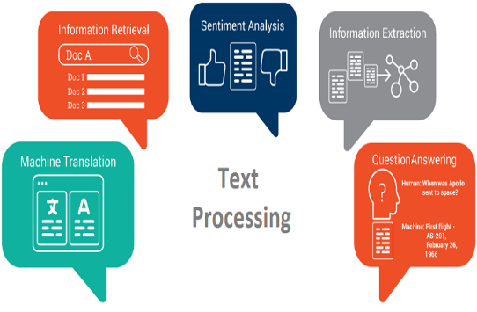

4.3 Understanding OT: IT interaction (Automation V-LAN’s and IT’s UJ Network)
4.3.1 Virtual Local Area Network
- A local area network (LAN) is a private network usually confined to one plant.
- Virtual LANs (VLANs) allow a single physical LAN to be partitioned into several smaller logical LANs.
- VLANs limit the broadcast domain, improve security and performance and are ideal for separating industrial automation systems from information technology systems.
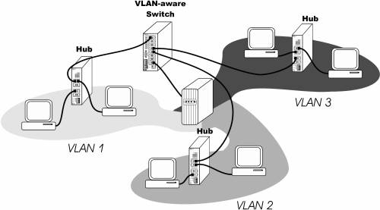

4.3.2 IT’s UJ Network
- An IT network is a group of interconnected devices, such as computers, servers, routers, and switches, that communicate with each other to share data and resources.
- IT networks consist of several components that work together to ensure efficient and secure data transmission.

These components include:

- Servers: Servers are powerful computers that store and manage data, applications, and services on the network.
- Clients: Clients are devices, such as desktop computers, laptops, and mobile devices, that connect to the network to access resources.
- Routers: Routers are network devices that connect multiple networks and route data packets between them.
- Switches: Switches are network devices that connect devices within the same network and facilitate communication between them.
- Firewalls: Firewalls are security devices that protect the network from unauthorized access, malware, and other security threats.

4.4 Understanding Industrial Automation Technology
- Industrial Automation is the use of control systems, including machines, actuators, sensors, processors, and networks to perform tasks, with the goal of automating production.
- Industrial automation is a wide range of machines, actuators, sensors, processors, and networks that work to connect industrial environment.

4.4.1 Types of Industrial Automation Systems
- Fixed Automation - has a set task, continuous workflow, large volume production, and a high barrier of entry.
- Programmable Automation - works well for making several dozens to thousands of units
- Flexible Automation - progress the processes seem to involve less human interaction and downtime while increasing the range of products produced on one machine or production line.
- Integrated Automation - Integrating devices and machines into a single control system that connects the dots between processes, production lines, and more.
4.5 Understanding MIS and MES
4.5.1 Management Information System
- Focuses on providing real-time industrial operational information for decision making at the organizational level of operations.
- Used for decision-making, and for the coordination, control, analysis, and visualization of information in an organization.
- Improve an organization's operational efficiency, add value to existing products, engender innovation and new product development, and help managers make better decisions
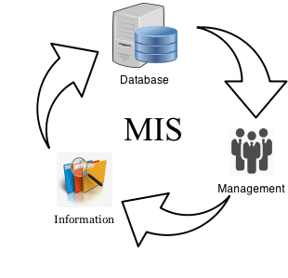
4.5.2 Management Execution System
- is a comprehensive, dynamic software system that monitors, tracks, documents, and controls the process of manufacturing goods—from raw materials to finished products.
- Providing a functional layer between enterprise resource planning (ERP) and process control systems.
- An MES gives decision-makers the data they need to make their plant floor more efficient.

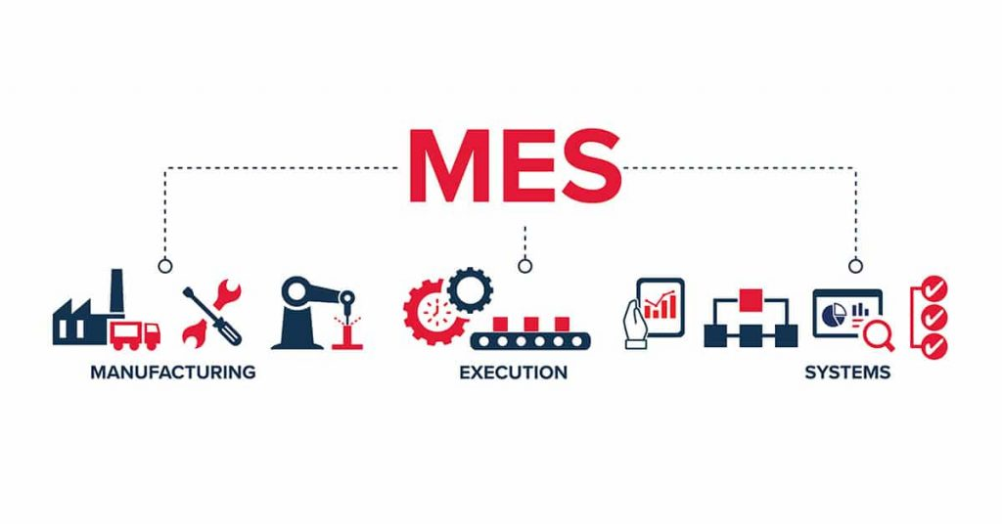

4.6 Understanding Levels (0-3/4) application in the industry and the OSI model
- In the industry, understanding network layers 0-3/4 (Physical, Data Link, Network, and Transport) is crucial, as they are fundamental to how data is transmitted and managed, as defined by the OSI model, which is a conceptual framework for network communication.
4.6.1 The OSI Model:
- The Open Systems Interconnection (OSI) model is a conceptual framework that divides network communications functions into seven layers.
- It provides a common basis for understanding and coordinating standards development for systems interconnection.
- The OSI model is a standard for discussing and teaching networking in the field of information technology.

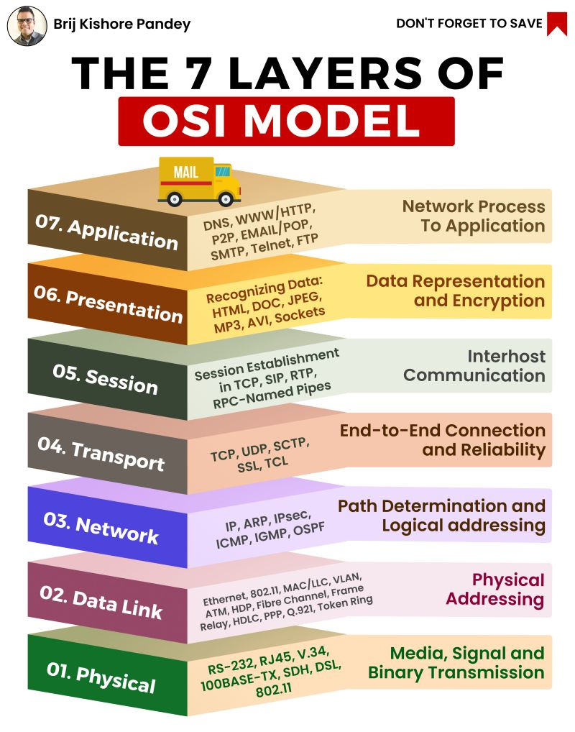

4.7 The MIS Job Specification
- A Management Information Systems (MIS) are responsible for managing and optimizing an organization’s information systems to ensure efficient data collection, processing, and reporting. They play a crucial role in analyzing data to support strategic decision-making and improve business operations.
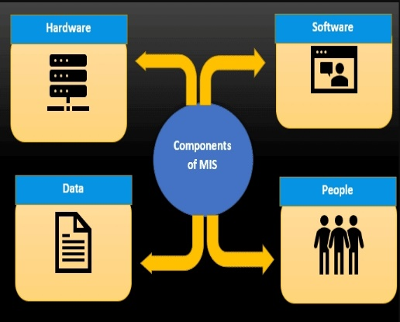

    - MIS Specialist Key Responsibilities
4.7.1.1 System Management and Maintenance
    - Oversee the installation, configuration, and maintenance of information systems.
    - Ensure system security, data integrity, and availability of information.
4.7.1.2 Data Analysis and Reporting
    - Collect, analyze, and interpret data to provide actionable insights for business strategy.
    - Develop and maintain dashboards, reports, and visualizations for various stakeholders.
    - Support data-driven decision-making processes across the organization.
4.7.2.3 Technical Support and Troubleshooting
    - Provide technical support for information systems, resolving issues promptly.
    - Train users in system functionalities and best practices
4.7.2.4 System Development and Integration
    - Identify opportunities for system improvements and innovations.
    - Design and implement system enhancements and integration with other business applications.

Chapter 5

END OF CHAPTER REPORT

Reporting Services

25 / 04 / 2025

TSUNDZUKANI NKUNA
MIS Automation Technician Trainee

This document is an end of chapter report that consists of information regarding reporting services such as SSRS and crystal reports. It details into specs on how to create your first SSRS and crystal reports using SQL and visual studio.

REPORTING SERVICES TABLE OF CONTENT

- Reporting Services ……………………………………………………………………………. Page 46
- Understanding reporting services (various reporting tools, e.g. crystal reports vs. SSRS)
  - What is SSRS? ..……………………………………………………………...…………. Page 46
1.1.1 Three types of SSRS reporting services are………………………………. Page 46
1.2 What are SAP Crystal Reports? …………………………………………………… Page 46
- Understanding dynamic reports and its application ……………………………... Page 47
3.1 what is dynamic reporting ………………………………………………………….... Page 47
3.2 Static vs. dynamic reports: what are the differences? ………………………. Page 47

- Reporting Services
“A company that tells a balanced story in its corporate reporting will be set apart from its peers and will build trust with its stakeholders.”
5.1 Understanding reporting services (various reporting tools, e.g. crystal reports vs. SSRS)
5.1.1 What is SSRS?
- SSRS stands for SQL Server Reporting Services is a reporting software that allows you to produce formatted reports with tables in the form of data, graph, images, and charts. These reports are hosted on a server that can be executed any time using parameters defined by the users. It is part of Microsoft SQL Server Services suite.

5.1.1.1 Three types of SSRS reporting services are:
  - Microsoft SQL Server Integration services which integrate data from different sources.
  - Microsoft SQL Server Analytical service which helps with the analysis of the data
  - Microsoft SQL Server Reporting service allows for generating a visual report of the data.
5.1.2 What are SAP Crystal Reports?
- SAP Crystal Reports is a Business Intelligence tool which is used to generate reports from both SAP and non-SAP data sources. It enables end users to generate reports that include exceptional visualizations and implement new business requirements into reports to reduce dependency on IT and Report developers.
- It is an effective tool for trend visualization, data analysis, and progress monitoring.
- SAP Crystal Reports can connect to any data source that includes Relational databases, or also with XML data. Together, these elements convert unprocessed data into insightful knowledge that facilitates decision-making and enhances corporate operations.

5.2 Understanding dynamic reports and their application
5.2.1 What is dynamic reporting?
- Dynamic reporting is a type of report that generates, or updates reports based on changes to the underlying data sources. Dynamic reports automatically update in response to data additions, modifications, or deletions from the source.

5.2.2 Static vs. dynamic reports: what are the differences?
- Static reports are traditional reports that are created once and then remain unchanged. Its purpose is to provide insight and guide decision-making. Typically, stakeholders receive these reports by printing or saving them. While static documents can help provide a snapshot of data at a specific time, they often need more flexibility and interactivity.

- Dynamic reports, no manual effort is required at all to either create or update the data. This report is best suited for quick decision-making based on up-to-date information. Lively reports are often web-based and can be accessed from anywhere and any device with internet connectivity. Unlike static reports, dynamic reporting offers flexibility and interactivity that allows further exploration.

Chapter 6

MIS Systems Regression Testing Report

Regression Testing Report

02 / 05 / 2025

TSUNDZUKANI NKUNA
MIS Automation Technician Trainee

6.1 H.C.B.P Client Line 1
    - H.C.B.P Active Delay System Client Line 1
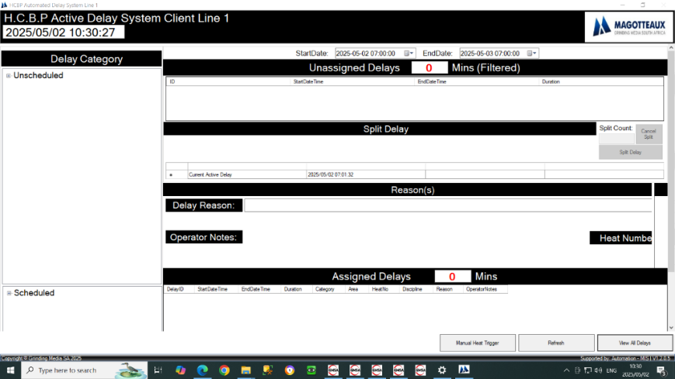
    - H.C.B.P Delays
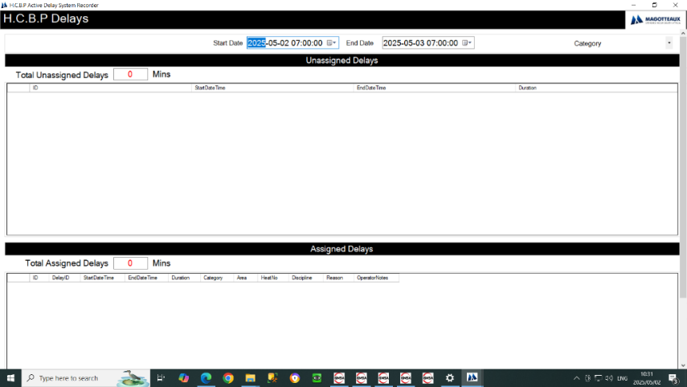
    - H.C.B.P Assigned Delay Edit

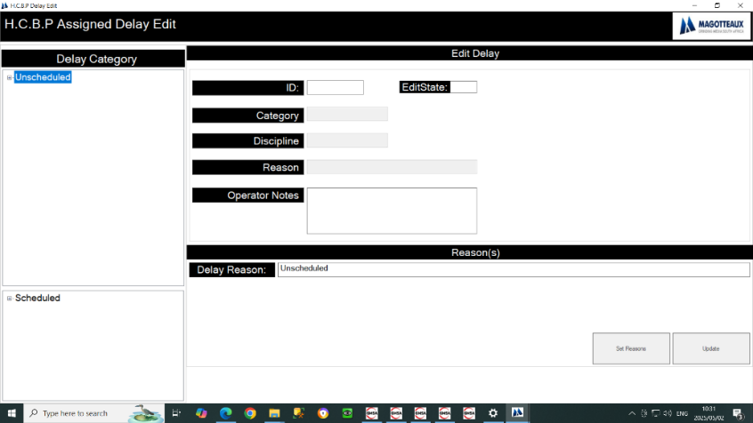

6.2 H.C.B.P Server Line 1
    - H.C.B.P Active Delay System Recorder Line 1
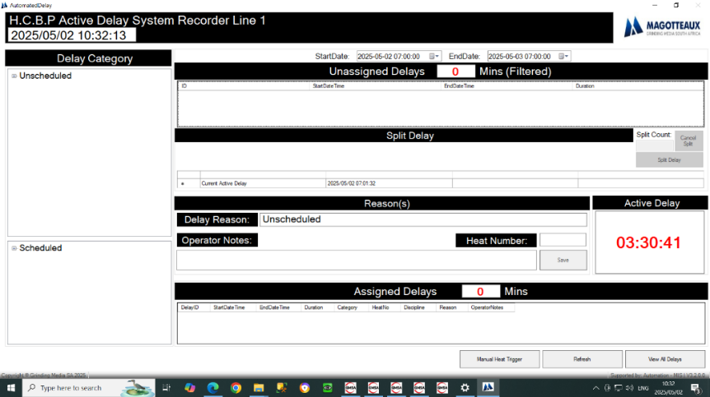
    - H.C.B.P Delays

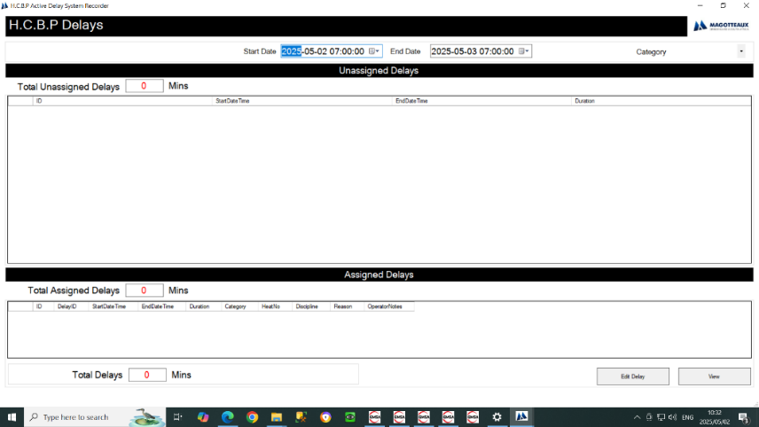
6.2.3 H.C.B.P Assigned Delay Edit
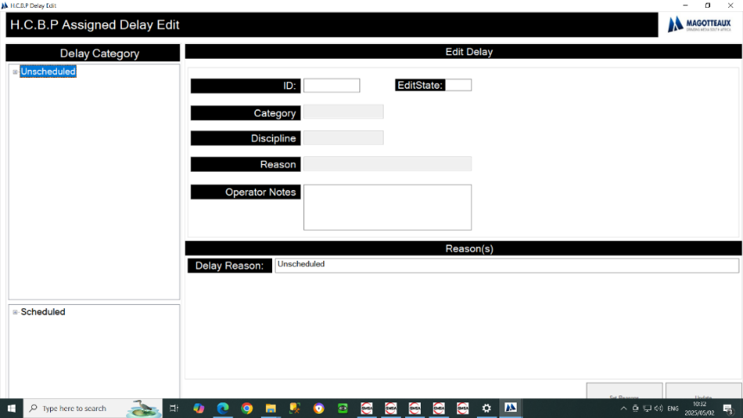

  - H.C.B.P Client Line 2
    - H.C.B.P Active Delay System Client Line 2
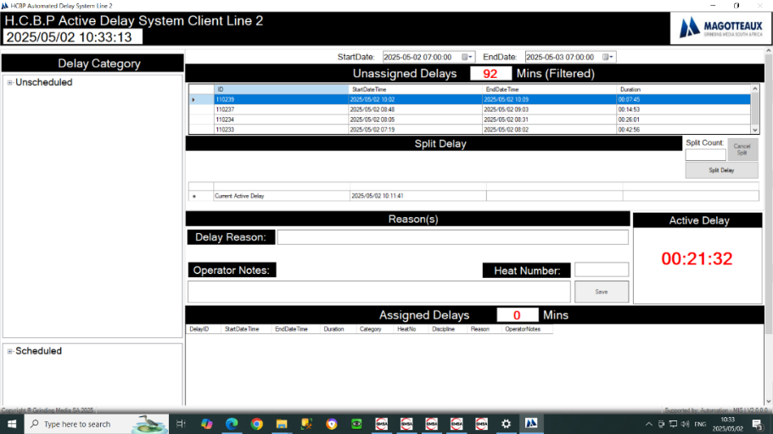
    - H.C.B.P Delays

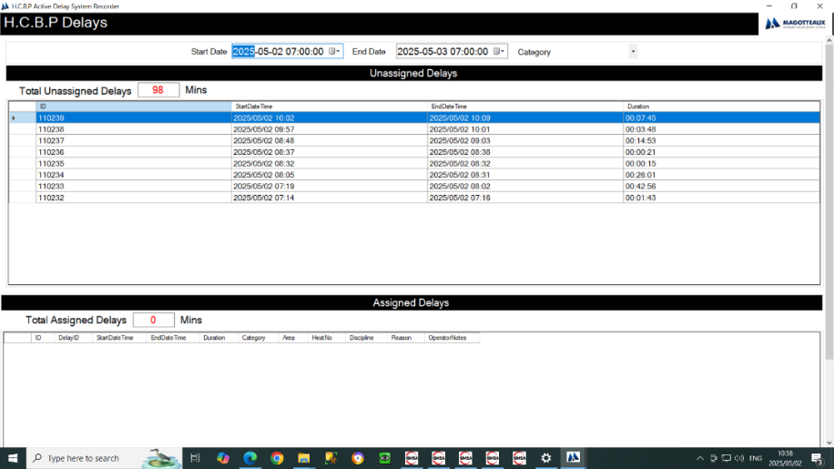
6.3.3 H.C.B.P Assigned Delay Edit

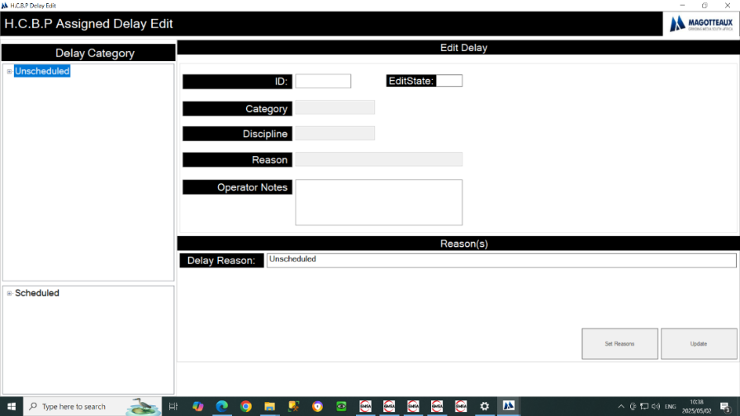

6.4 H.C.B.P Server Line 2
    - H.C.B.P Active Delay System Recorder Line 2
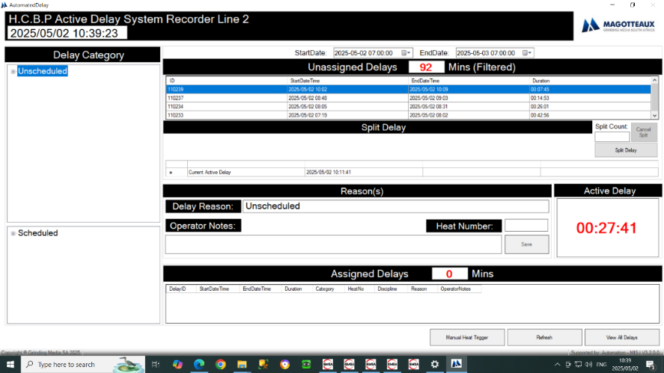
    - H.C.B.P Delays
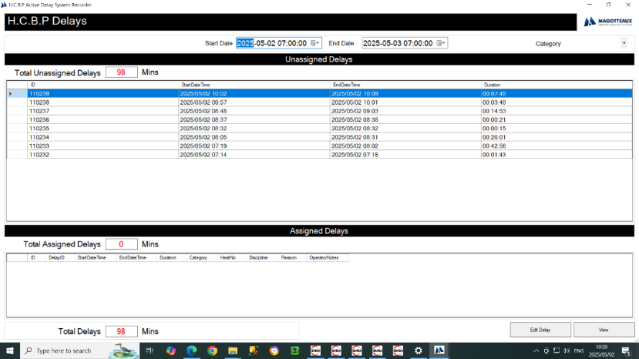
6.4.3 H.C.B.P Assigned Delay Edit
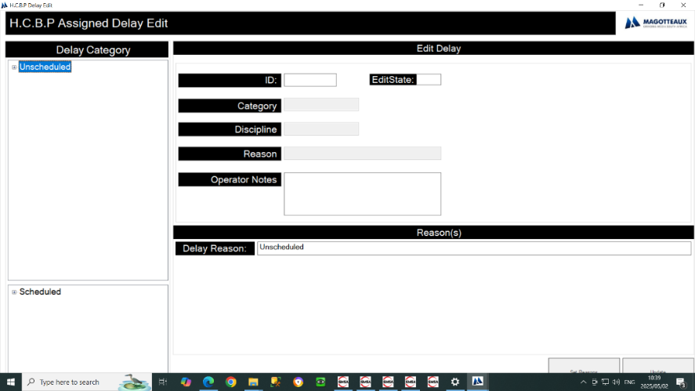

6.5 H.C.B.P Client Line 3
    - H.C.B.P Active Delay System Client Line 3
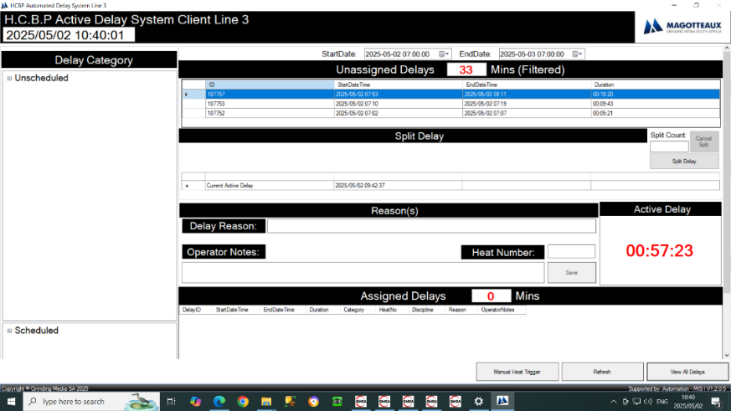
    - H.C.B.P Delays
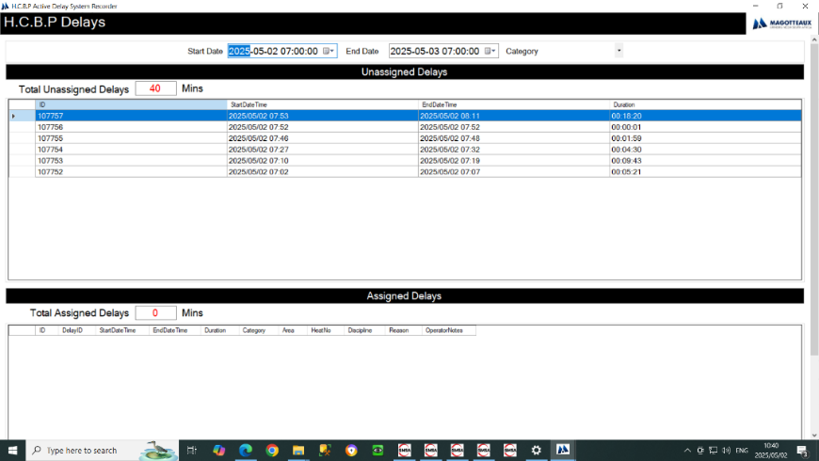
6.5.3 H.C.B.P Assigned Delay Edit
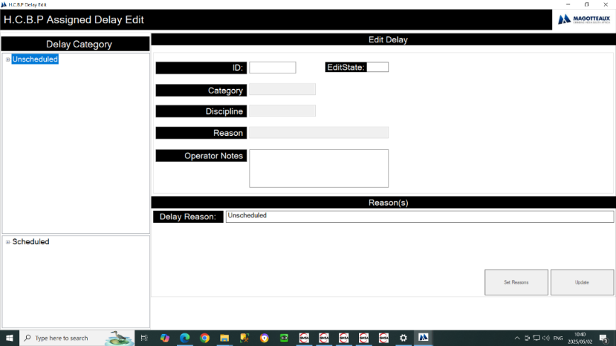

6.6 H.C.B.P Server Line 3
    - H.C.B.P Active Delay System Recorder Line 3
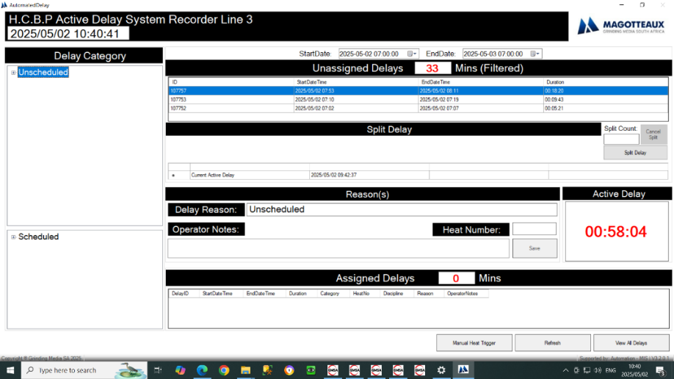
    - H.C.B.P Delays

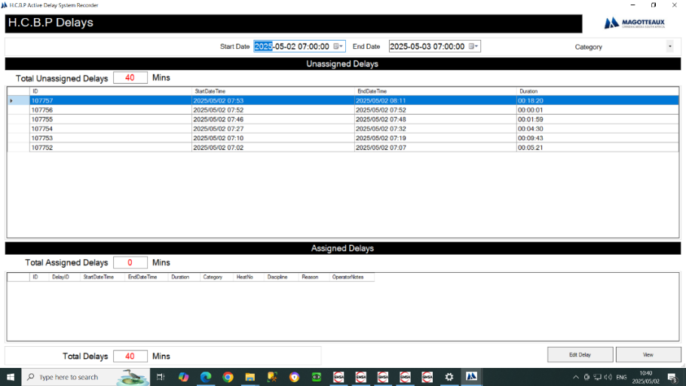
6.6.3 H.C.B.P Assigned Delay Edit

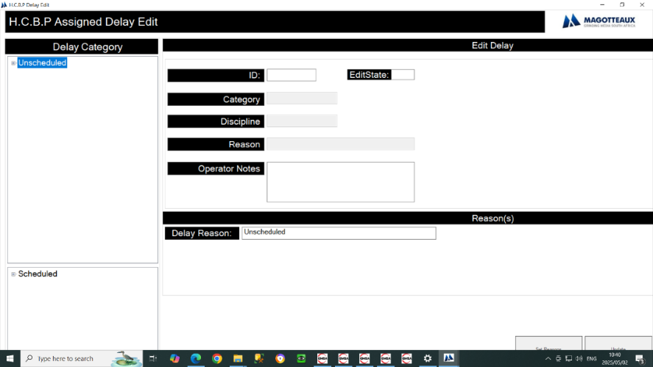

  - H.C.B.P Disa Log Sheet
    - H.C.B.P Disa Chemistry
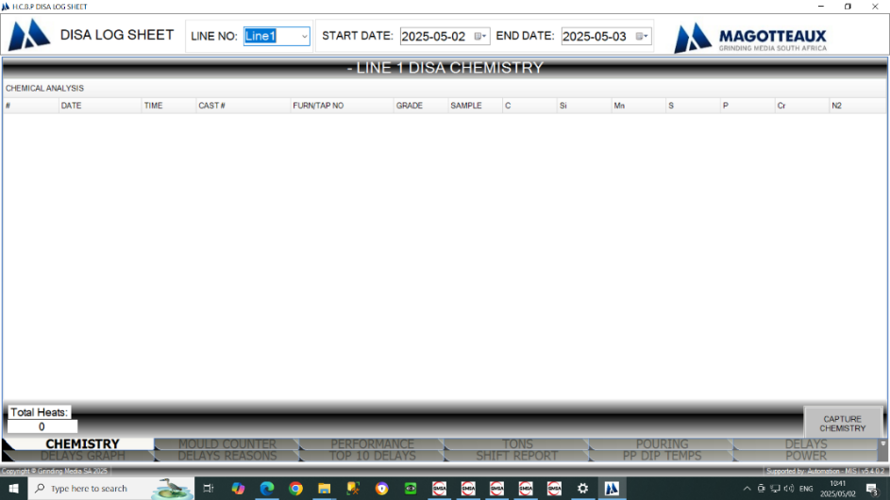
    - H.C.B.P Disa Mould Counter
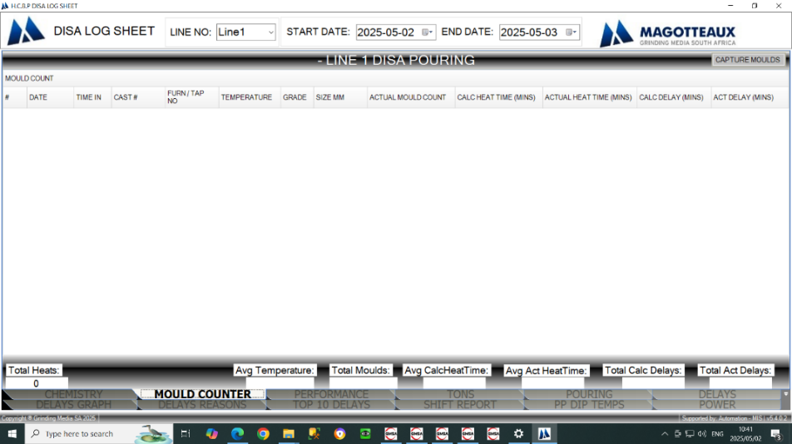
    - H.C.B.P Disa Pouring Perfomance Indicators
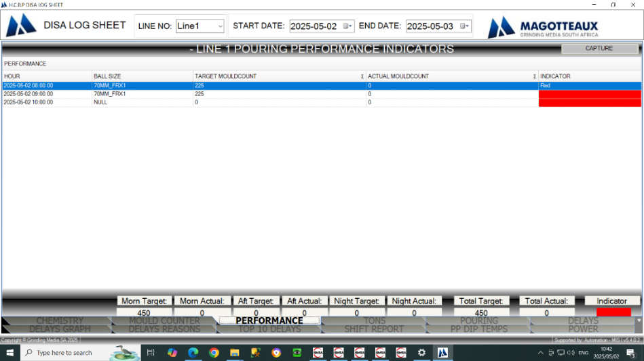

    - H.C.B.P Disa Pouring Daily Production (TONS)
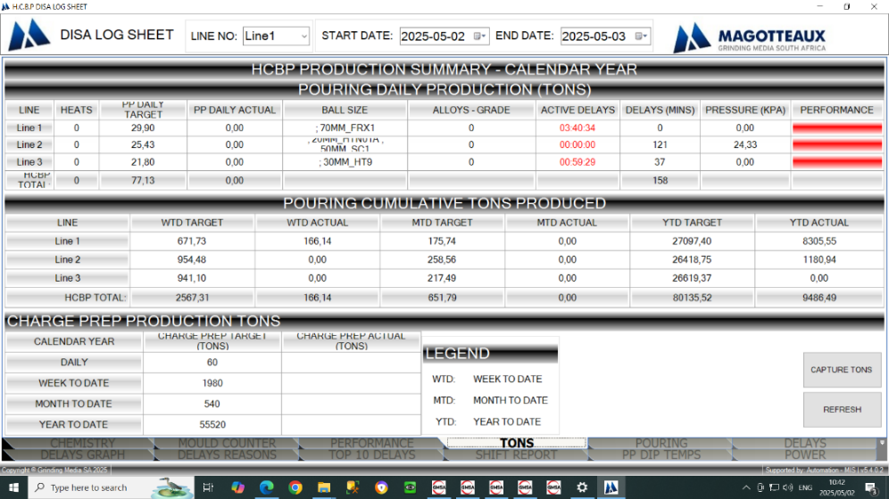
    - H.C.B.P Disa Active HCBP Pouring Campaign
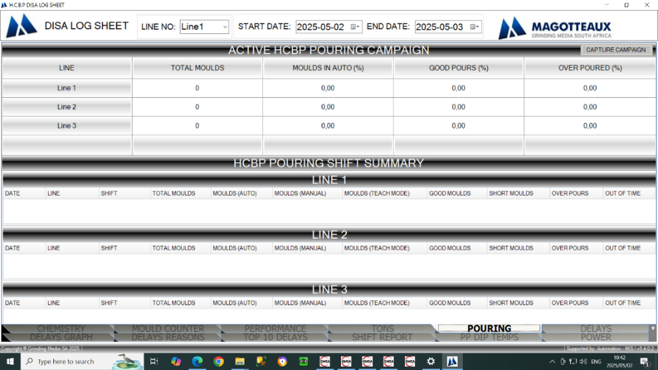
    - H.C.B.P Disa Delays
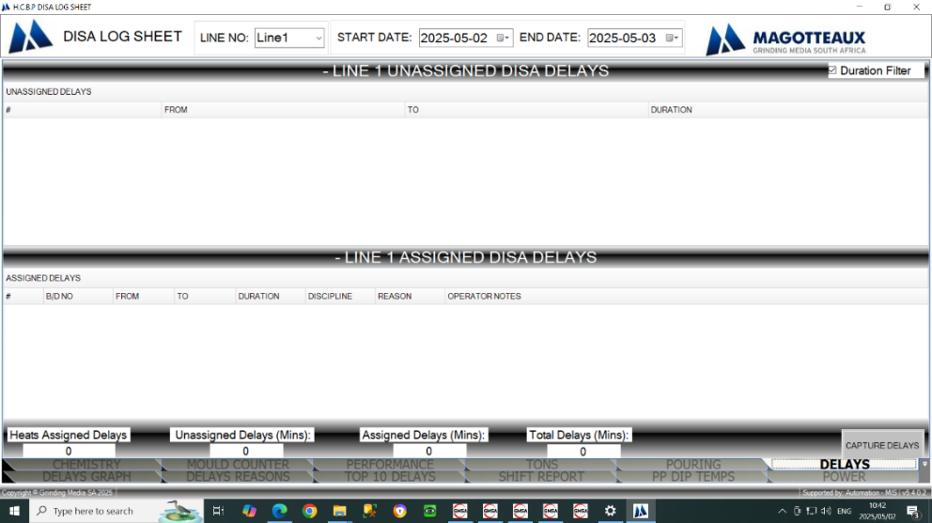

    - H.C.B.P Disa Graphical Assigned Delay Discipline Summary
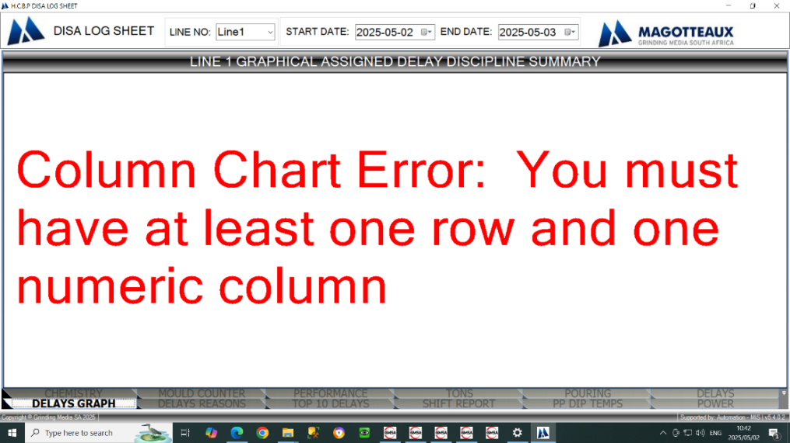
    - H.C.B.P Disa Total Delay Duration (mins) Per Reason
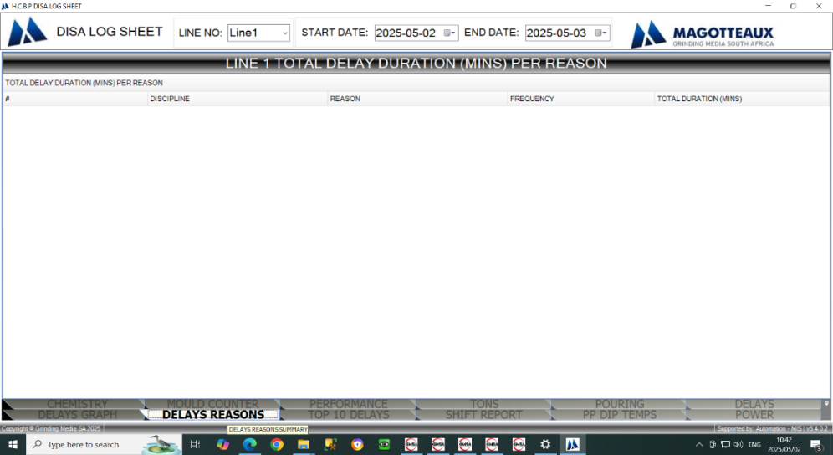

    - H.C.B.P Disa Top 10 Longest Delay Duration (mins)
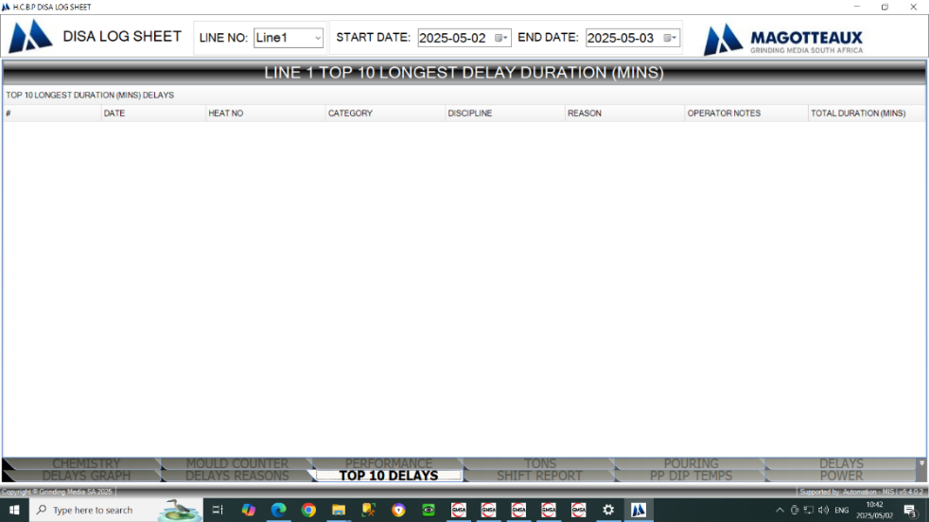
    - H.C.B.P Disa Artisan and Forman Shift Report
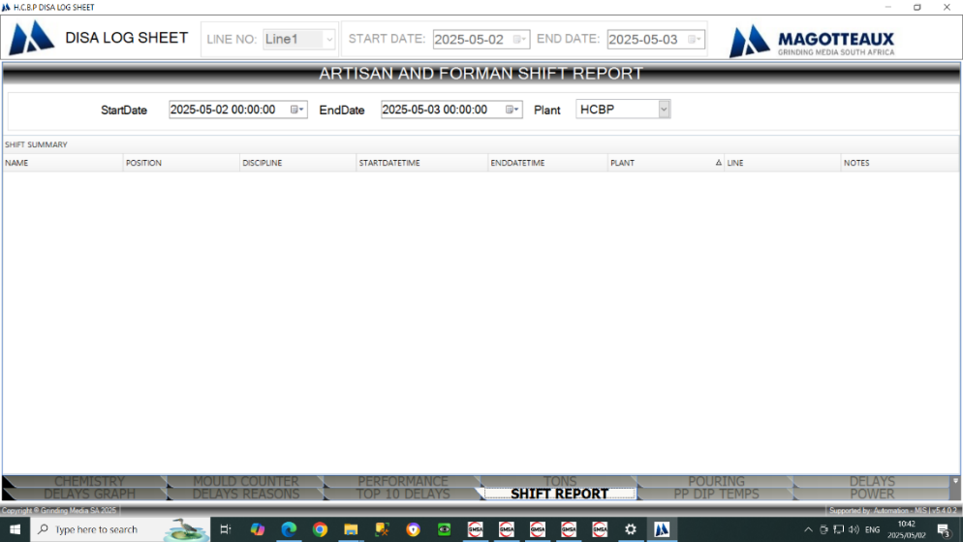
    - H.C.B.P Disa Press Pour Dip Temperatures
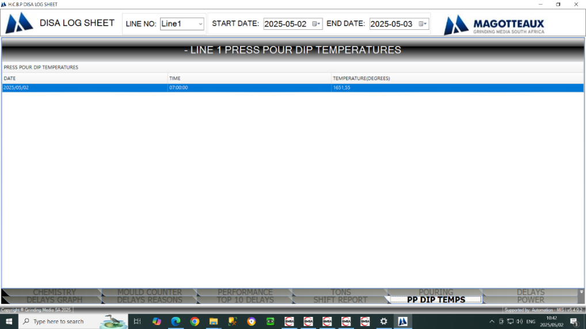
6.7.12 H.C.B.P Disa Grinding Media SA Power Consumption
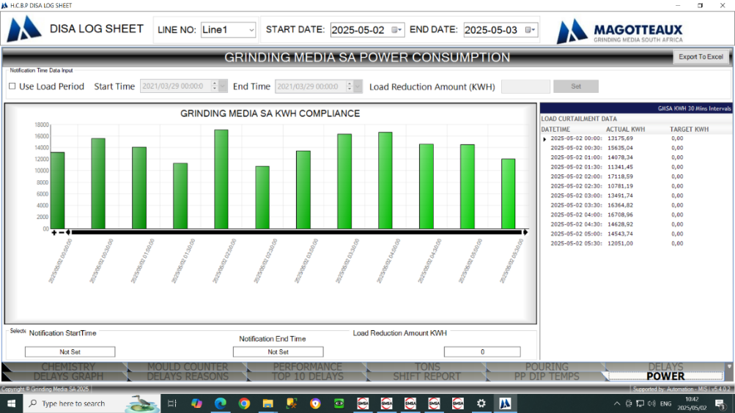

  - H.C.B.P Induction Furnace A Client
    - H.C.B.P Furnace A Active Delay System Client
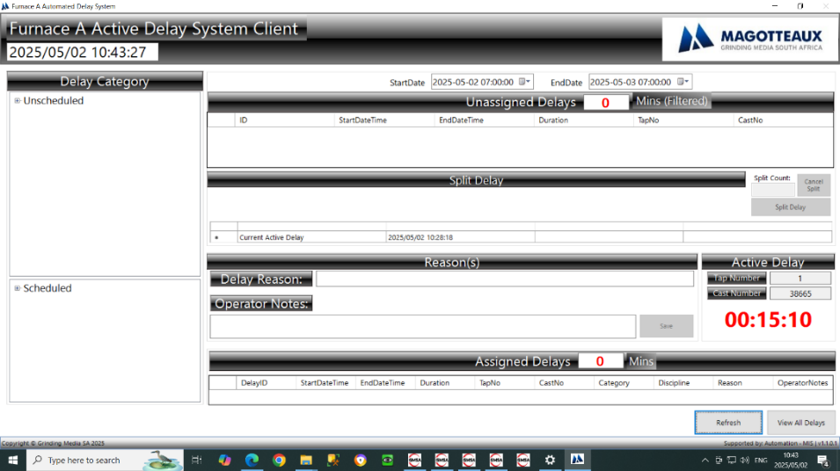
    - H.C.B.P Furnace A Delays
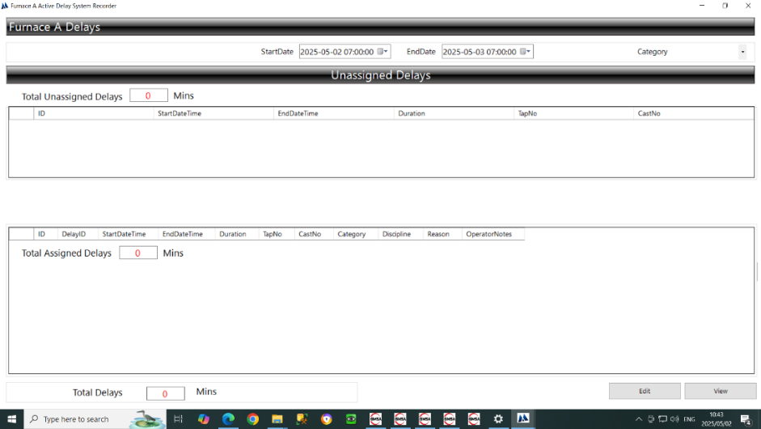
6.8.3 H.C.B.P Furnace A Assigned Delay Edit
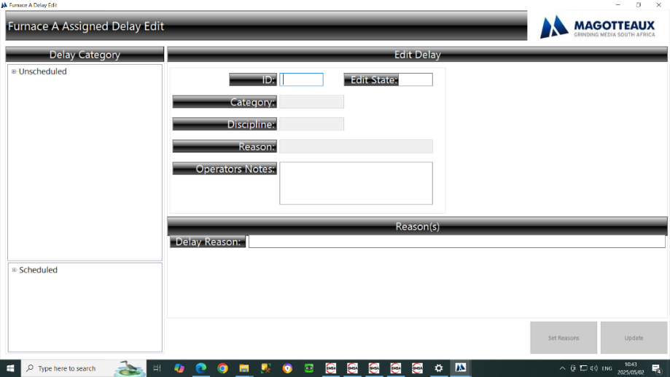
  - H.C.B.P Induction Furnace A Server
    - H.C.B.P Furnace A Active Delay System Recorder
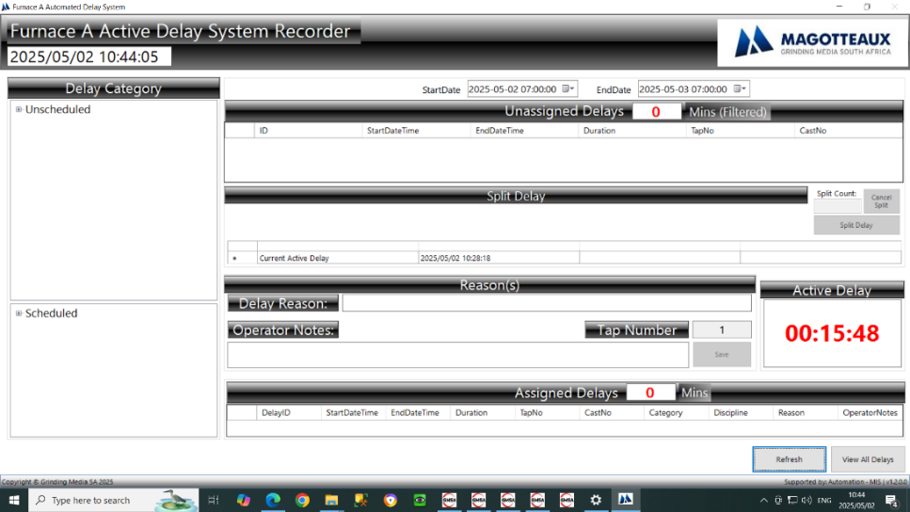
    - H.C.B.P Furnace A Delays
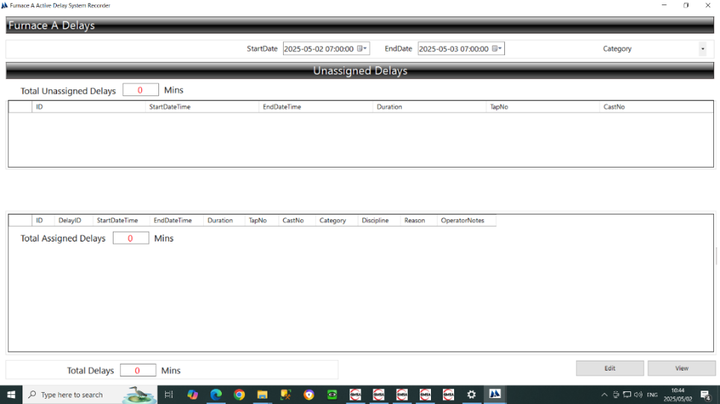
6.9.3 H.C.B.P Furnace A Assigned Delay Edit
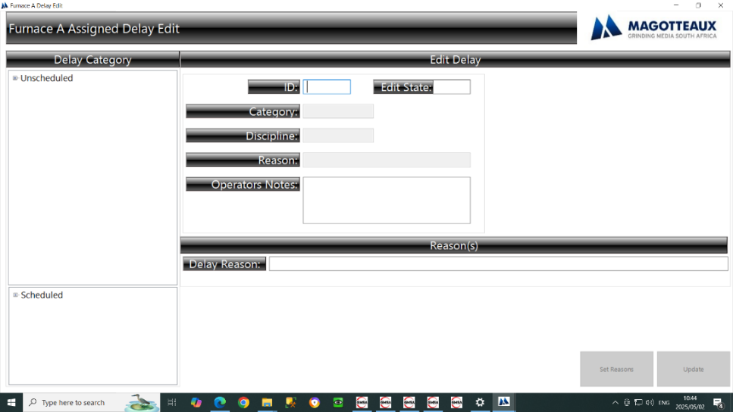
  - H.C.B.P Induction Furnace B Client
    - H.C.B.P Furnace B Active Delay System Client
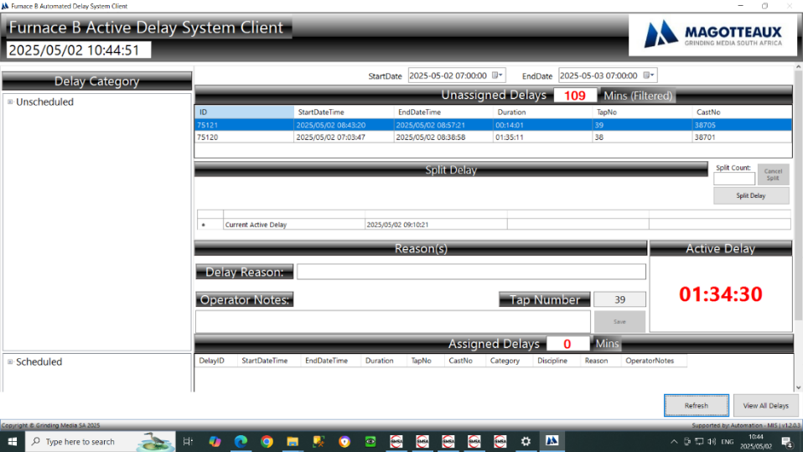
    - H.C.B.P Furnace B Delays
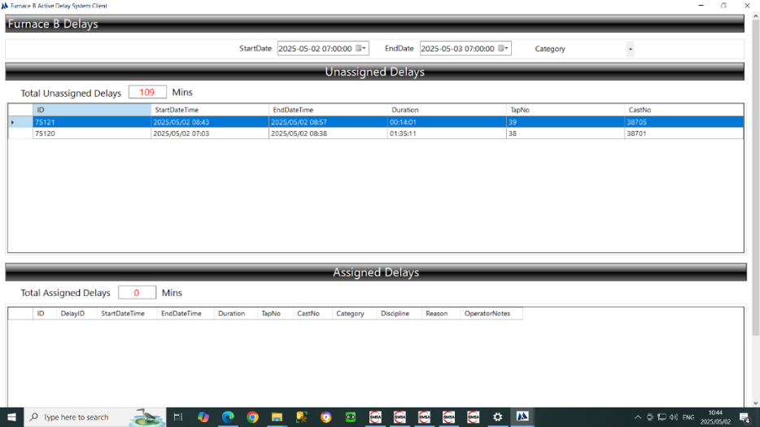
6.10.3 H.C.B.P Furnace B Assigned Delay Edit
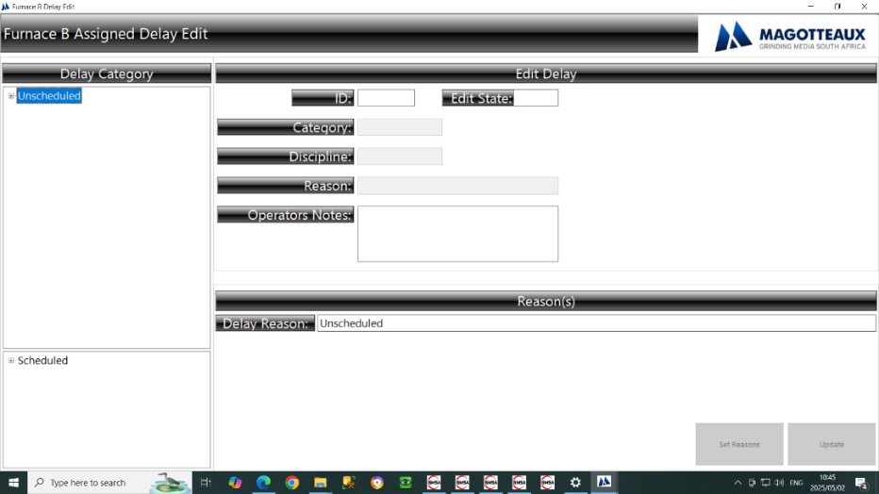
  - H.C.B.P Induction Furnace B Server
    - H.C.B.P Furnace B Active Delay System Recorder
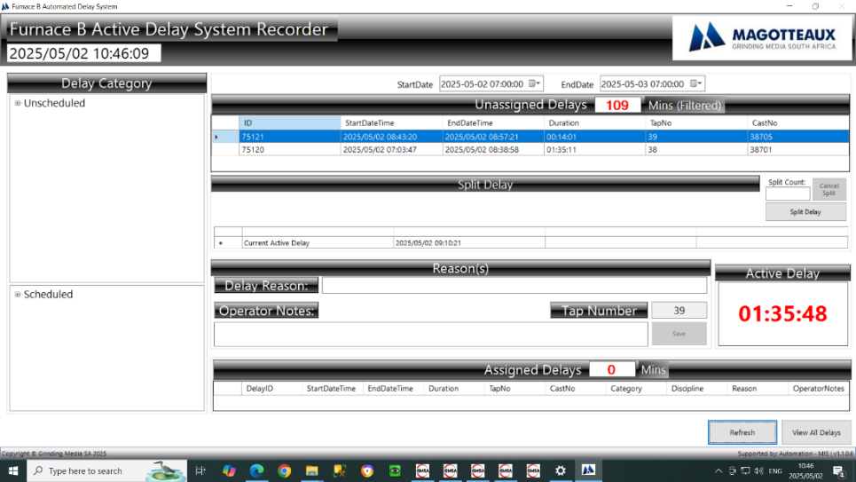
    - H.C.B.P Furnace B Delays
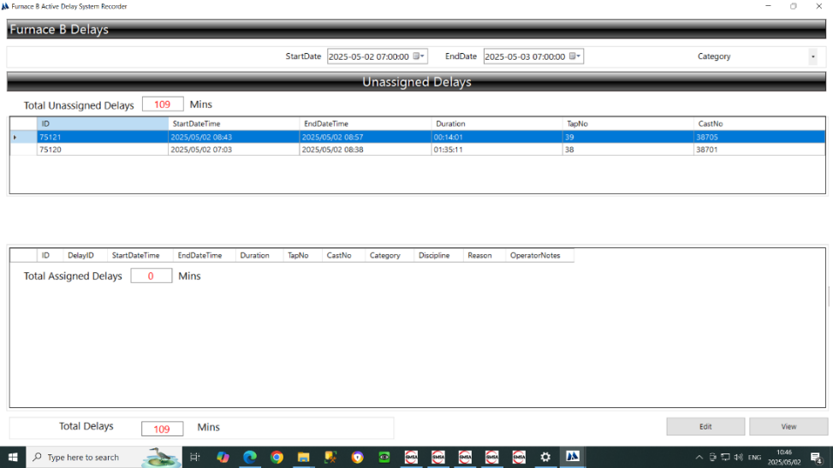
6.11.3 H.C.B.P Furnace B Assigned Delay Edit
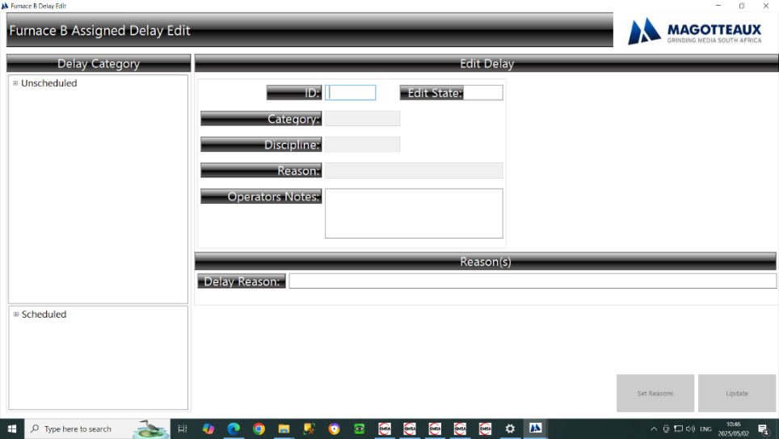
  - H.C.B.P Induction Furnace C Client
    - H.C.B.P Furnace C Active Delay System Client
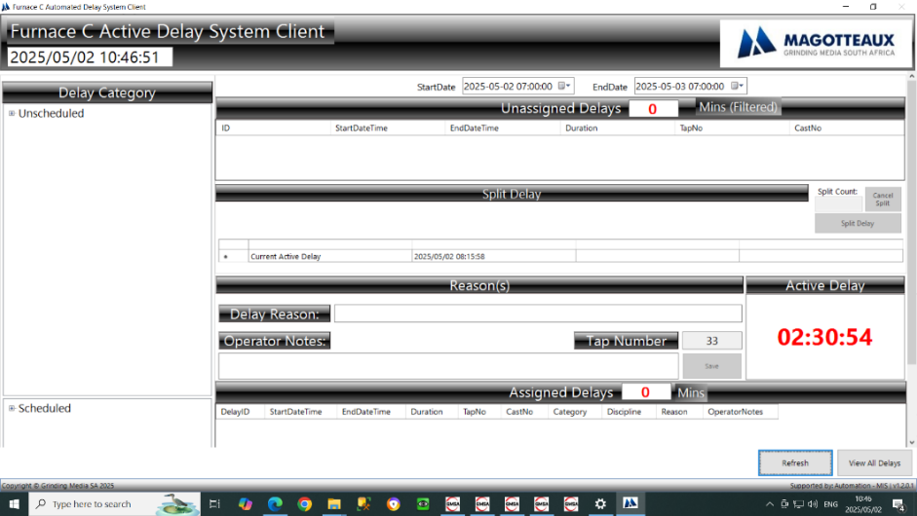
    - H.C.B.P Furnace C Delays
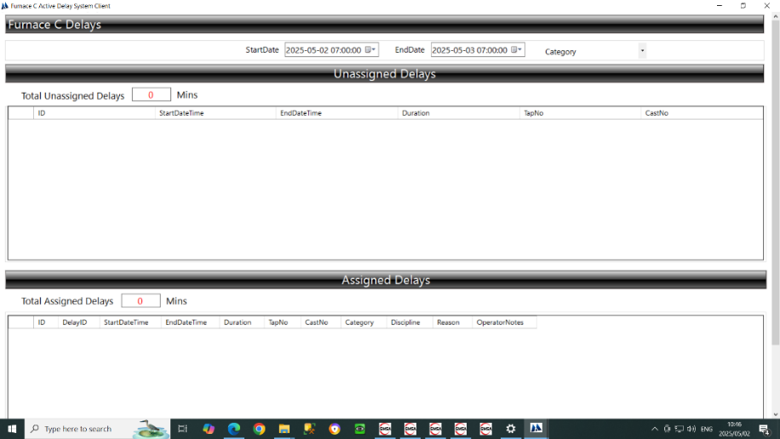
6.12.3 H.C.B.P Furnace C Assigned Delay Edit
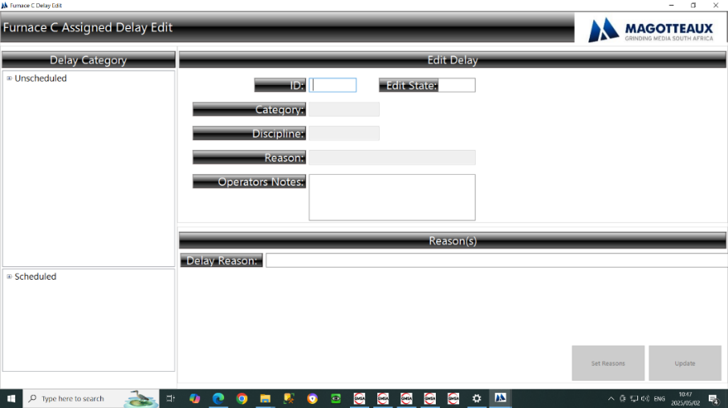
  - H.C.B.P Induction Furnace C Server
    - H.C.B.P Furnace C Active Delay System Recorder
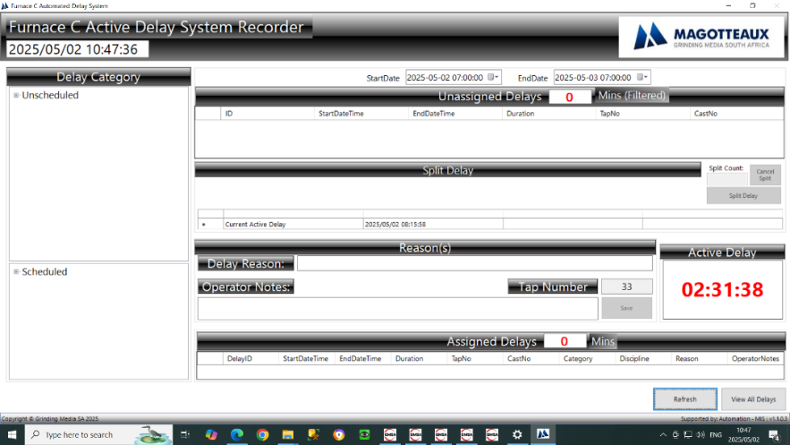
    - H.C.B.P Furnace C Delays
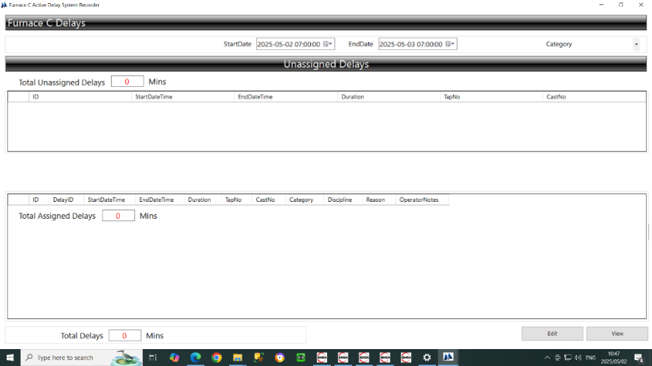
6.13.3 H.C.B.P Furnace C Assigned Delay Edit
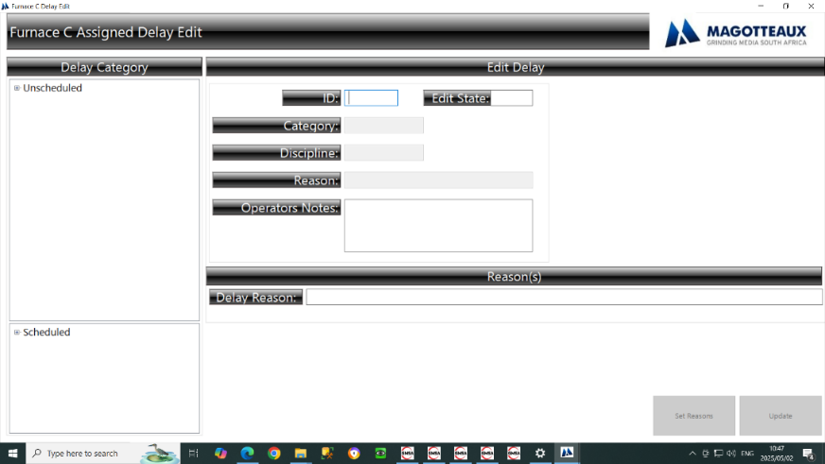

  - H.C.B.P Induction Furnace Reporter
    - H.C.B.P Induction Furnace Reporter
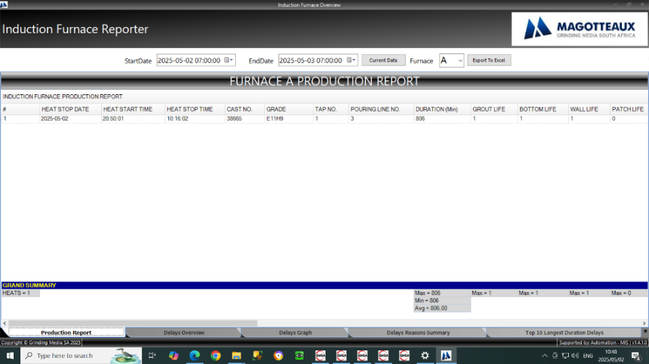
    - H.C.B.P Induction Furnace Delays Overview
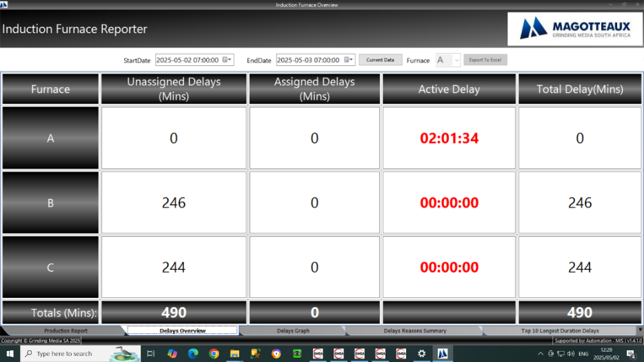
    - H.C.B.P Induction Furnace A Active Delay System Recorder
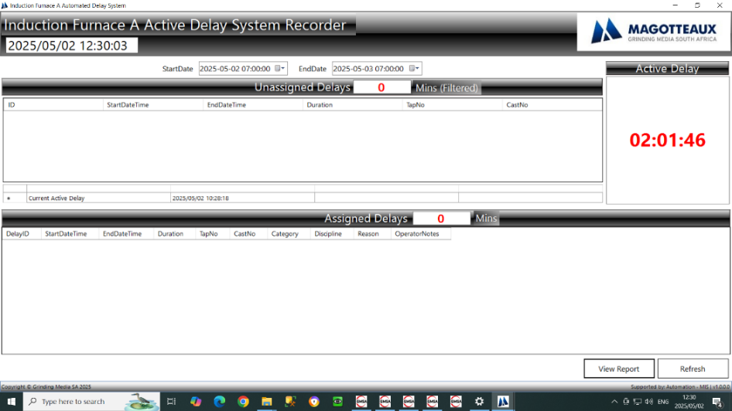

    - H.C.B.P Induction Furnace A Reporter
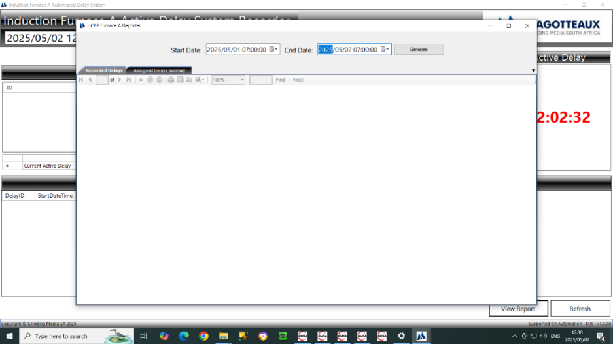
    - H.C.B.P Induction Furnace B Active Delay System Recorder
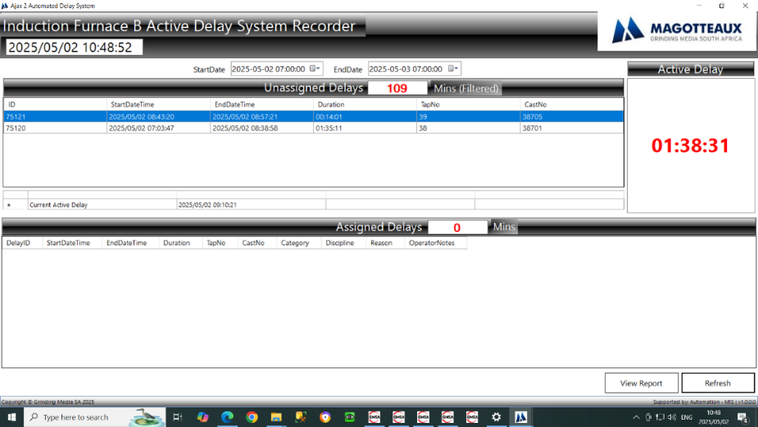
    - H.C.B.P Induction Furnace B Reporter
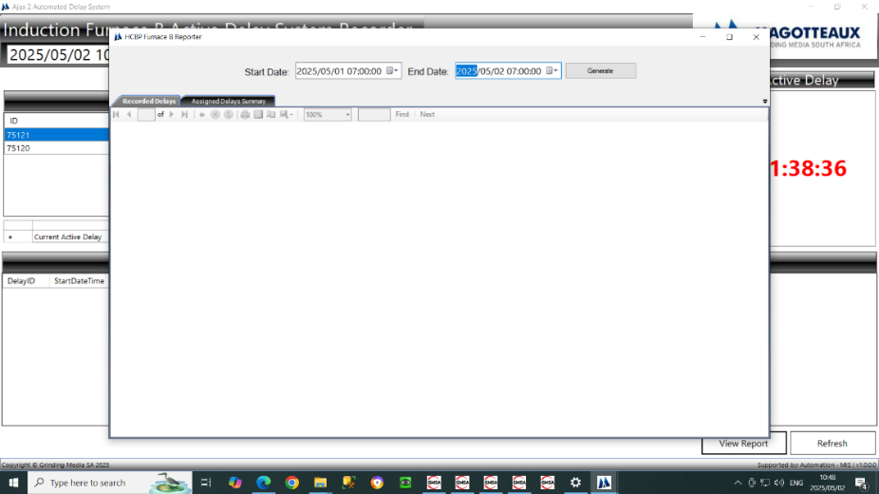

    - H.C.B.P Induction Furnace C Active Delay System Recorder
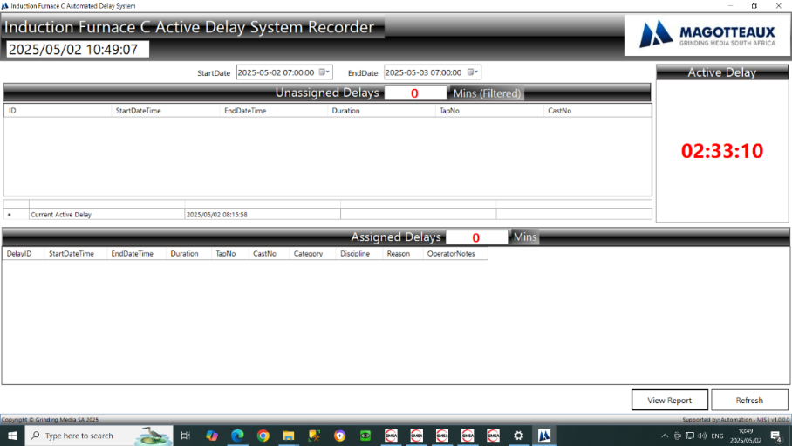
    - H.C.B.P Induction Furnace C Reporter
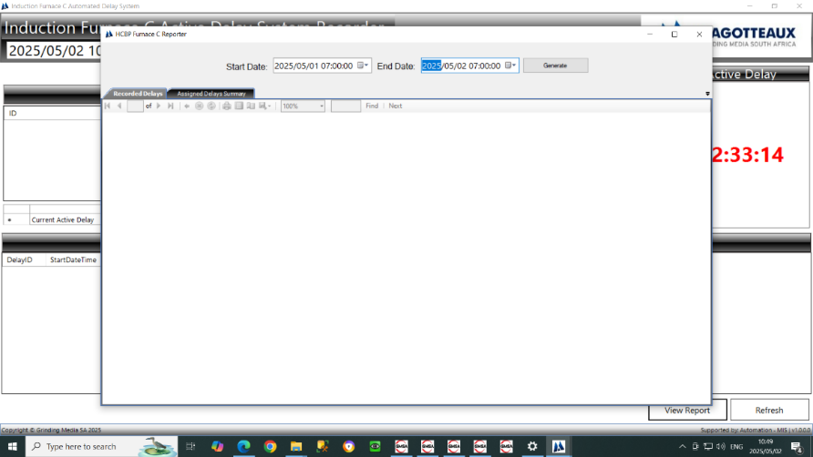
6.14.9 H.C.B.P Furnace A Graphical Assigned Delay Discipline Summary
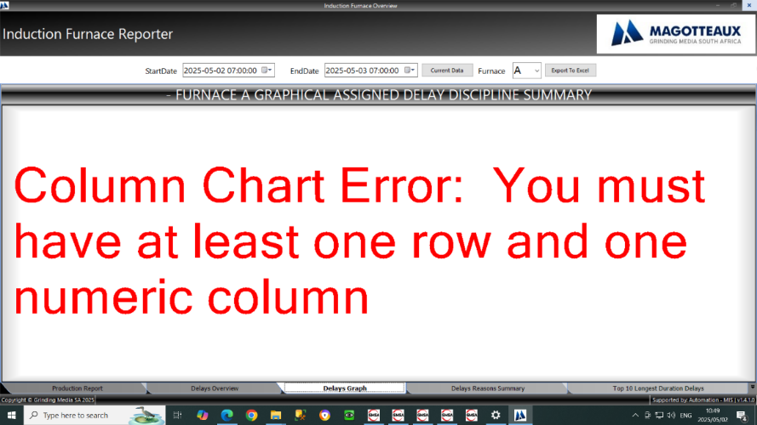

    - H.C.B.P Furnace A Total Delay Duration (mins) Per Reason

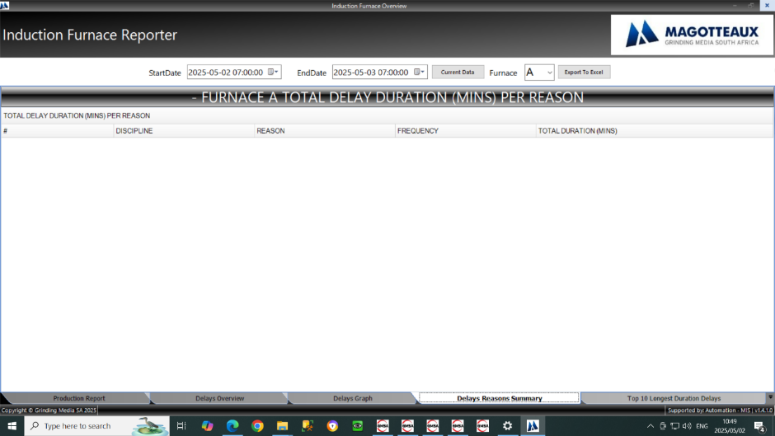

    - H.C.B.P Furnace A Total Delay Duration (mins) Per Reason

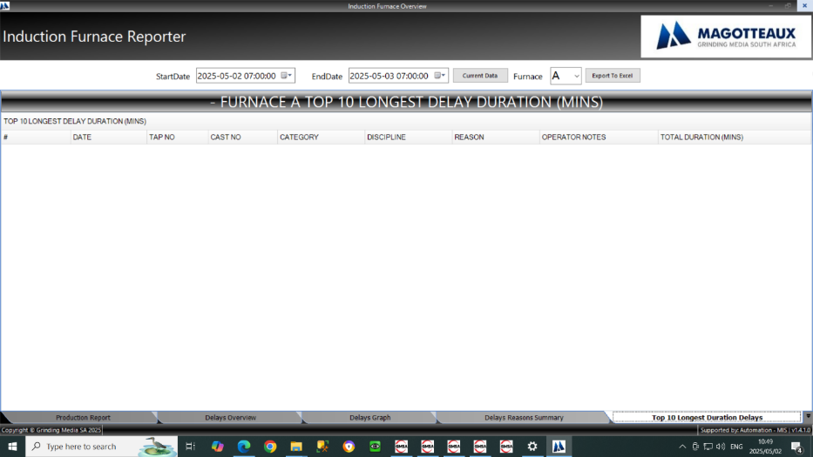

  - H.C.B.P Chemistry Analysis
    - H.C.B.P Chemistry Line 1
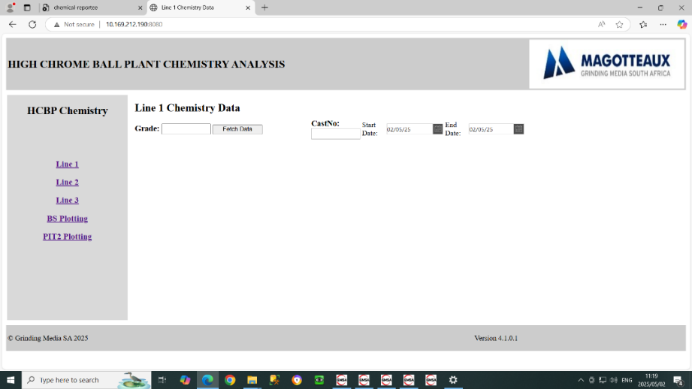
    - H.C.B.P Chemistry Line 2
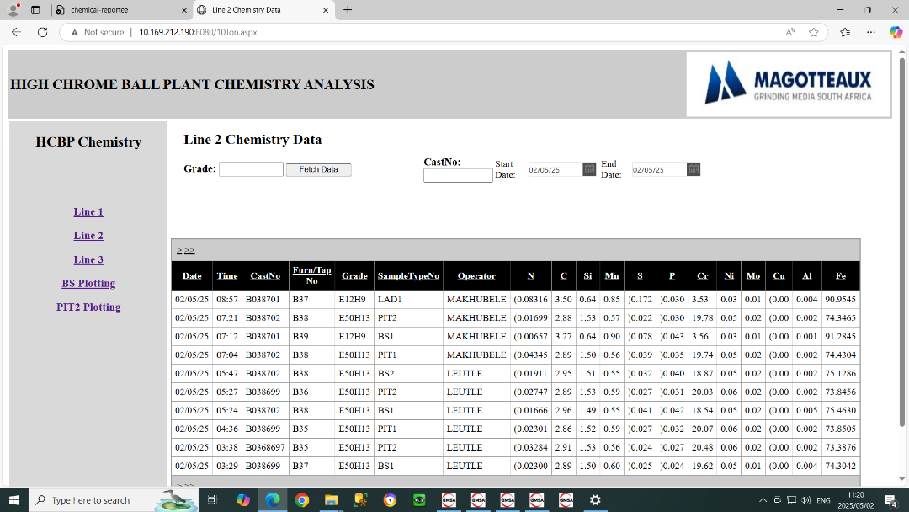
    - H.C.B.P Chemistry Line 3
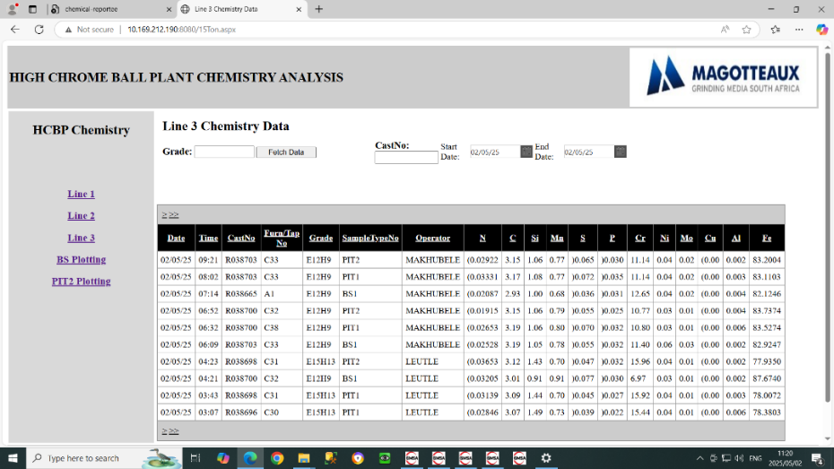
    - H.C.B.P Chemistry BS Plotting
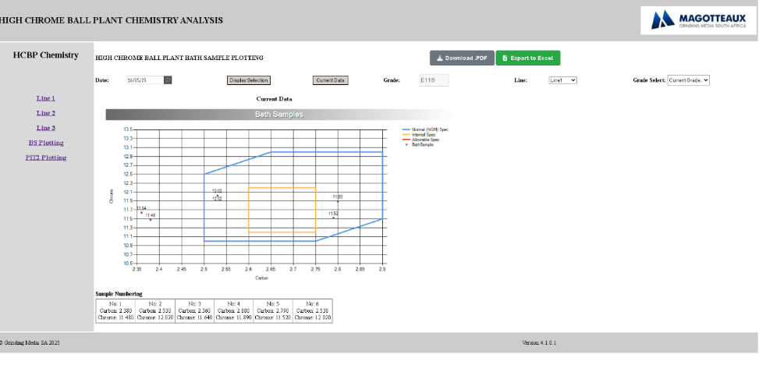
6.15.5 H.C.B.P Chemistry PIT2 Plotting
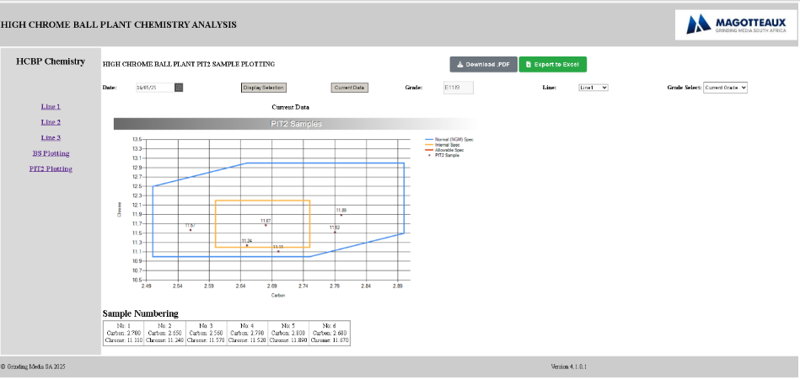

6.15.6 Exported Data to Excell

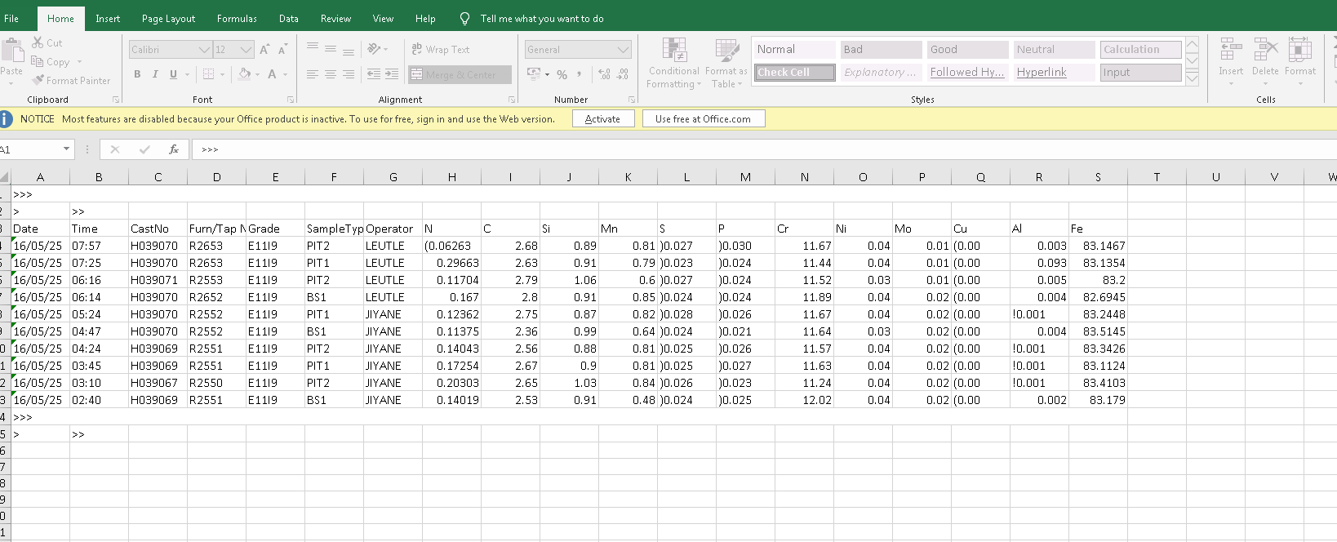
6.15.7 Downloaded Pdf Page
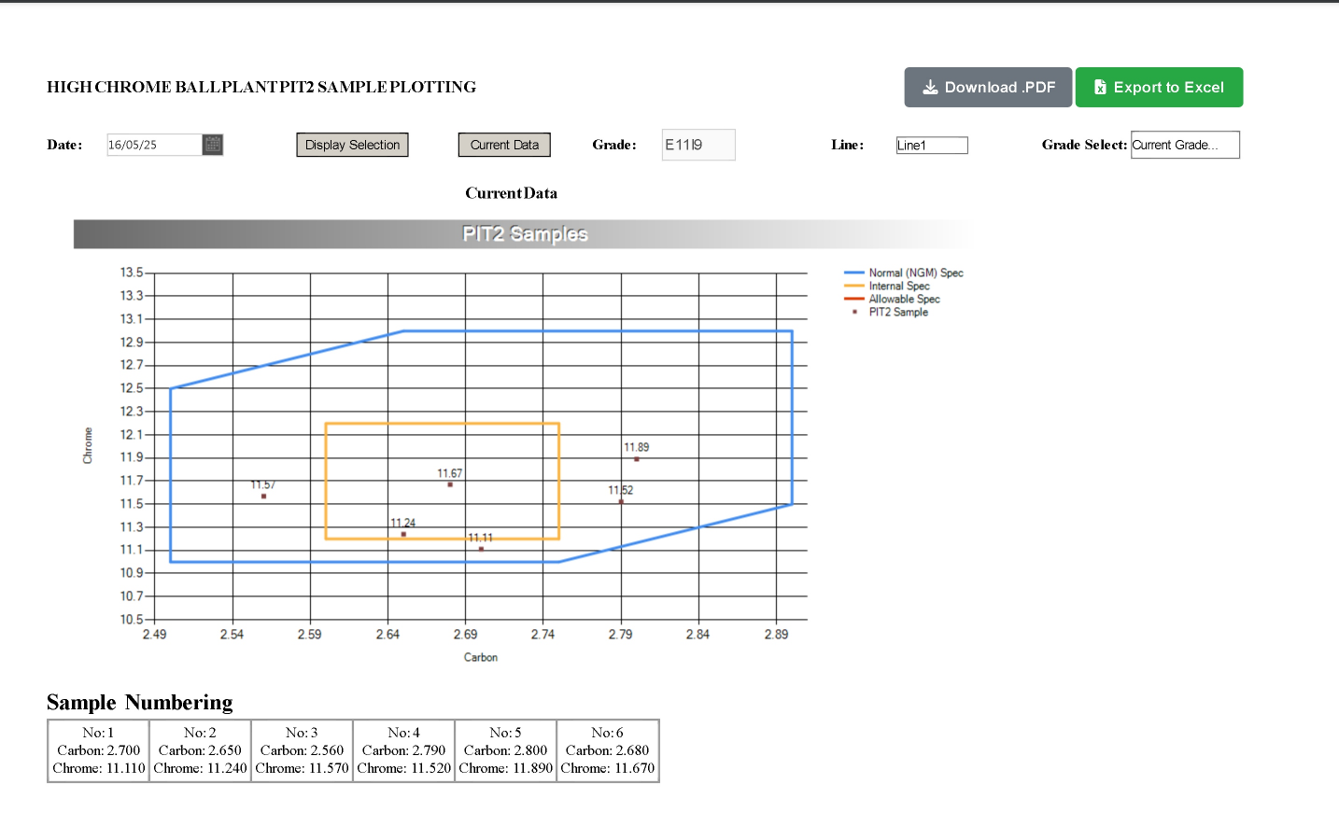

Chapter 7

MIS Systems Static Reports

SQL Server Reporting Services Report

16 / 05 / 2025

TSUNDZUKANI NKUNA
MIS Automation Technician Trainee

7.1 Static Reports
7.1.1 Static Reports Subscriptions
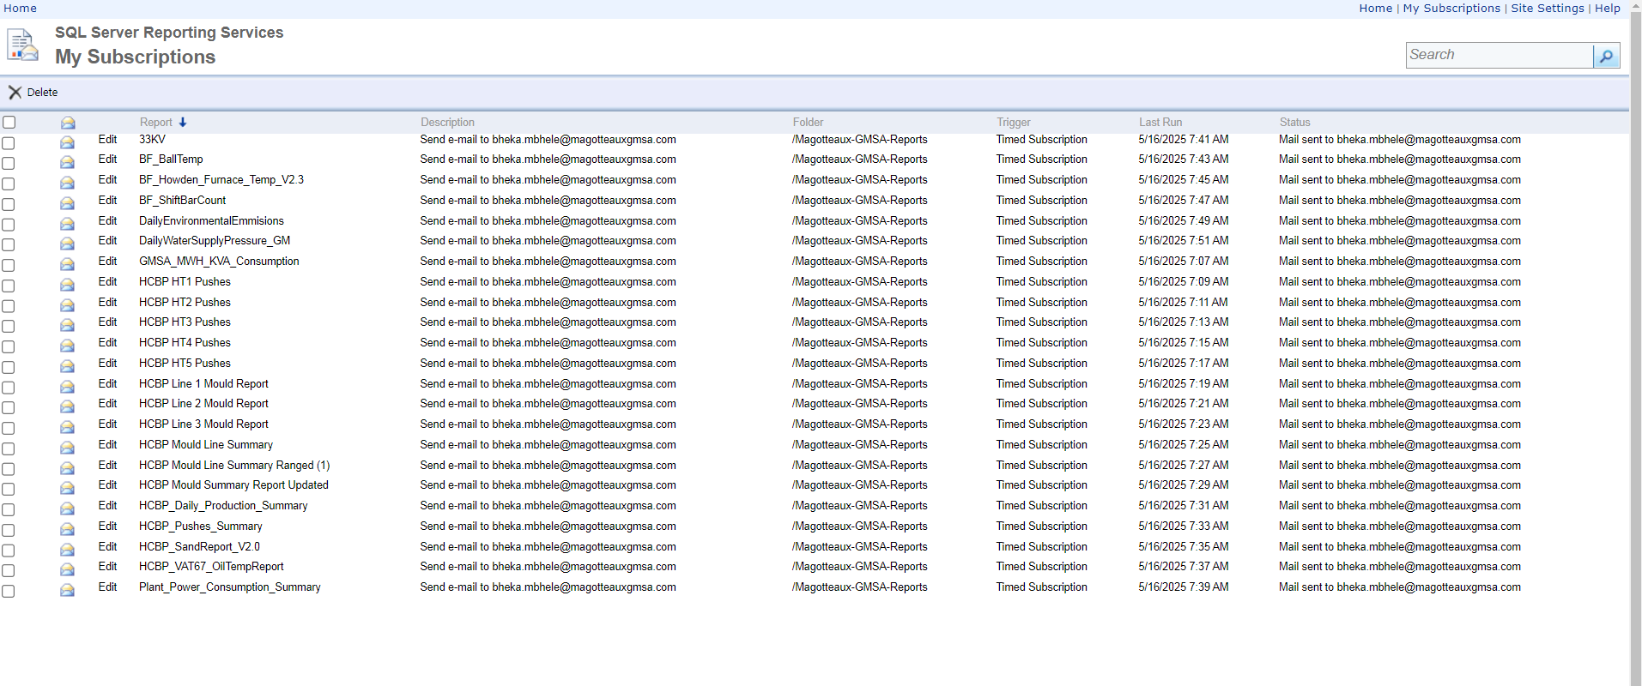

7.1.2 HCBP Heat Treatment 4 Pushes
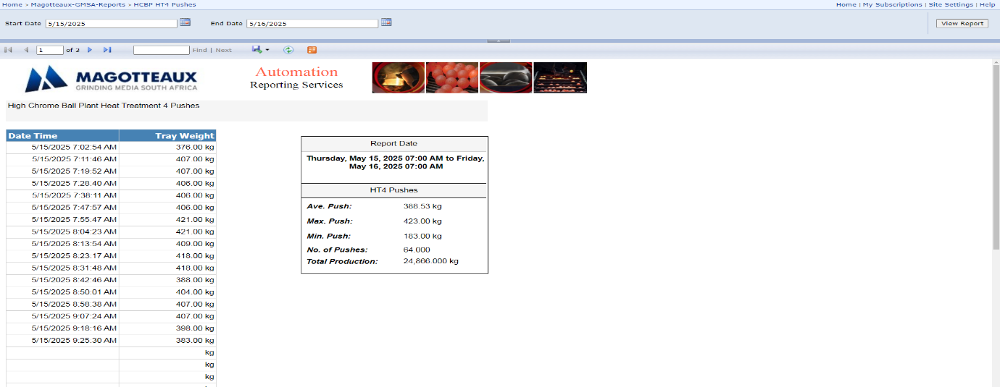

7.1.3 HCBP Heat Treatment 1 Pushes
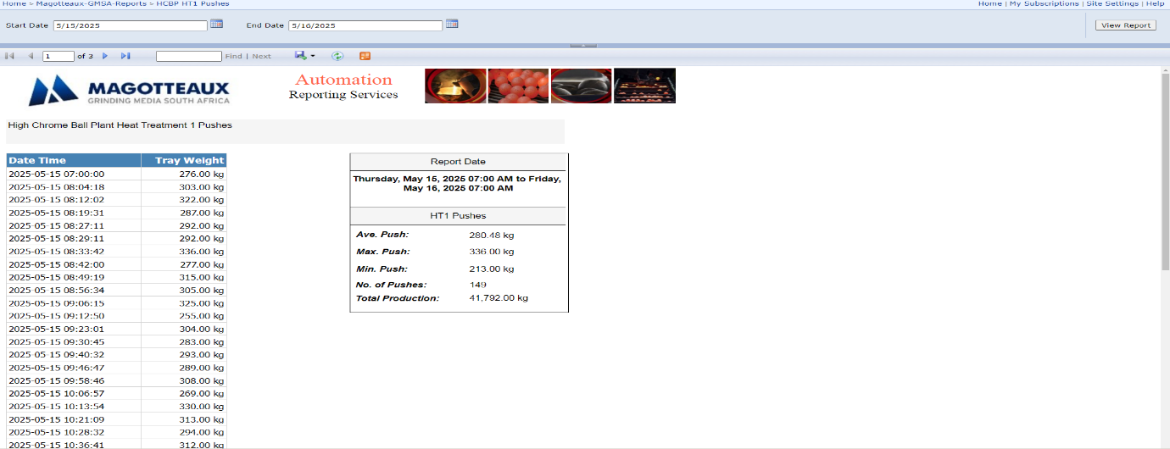
7.1.4 HCBP Vat 6 and 7 Oil Temperature Report
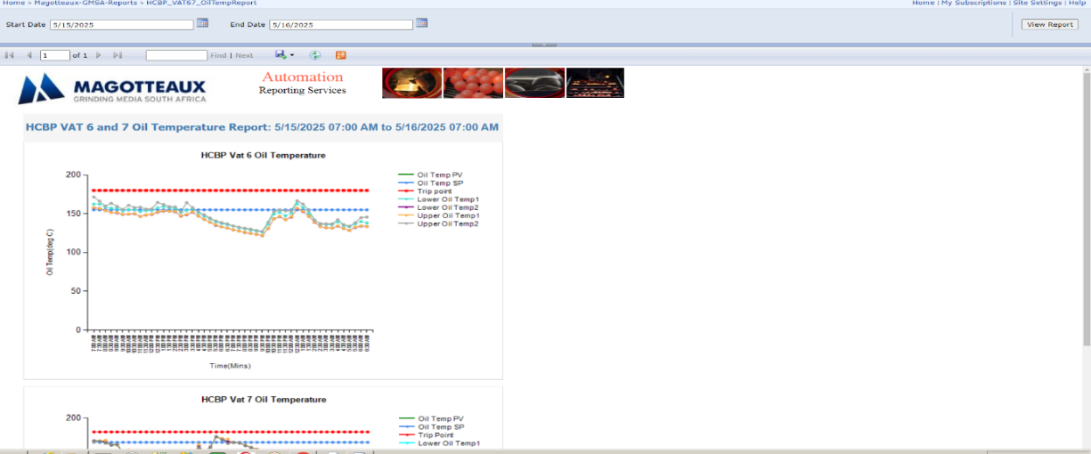

7.1.5 Ball Forge Daily Shift Bar Report
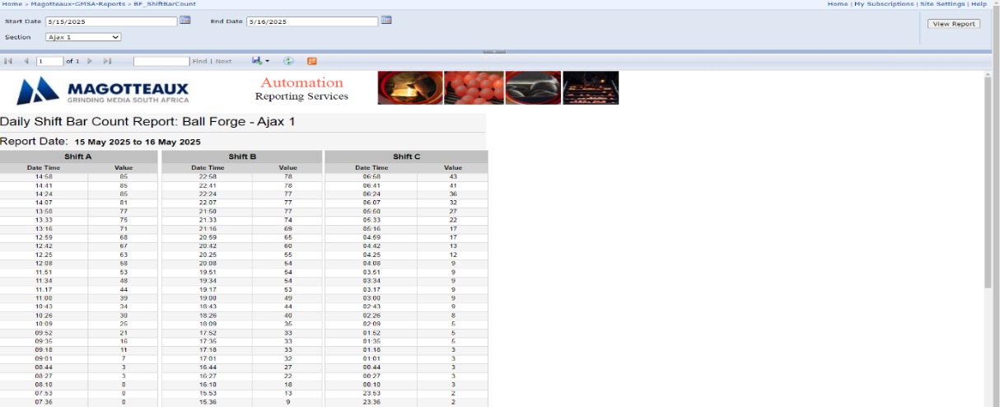

7.1.6 HCBP Sand Report
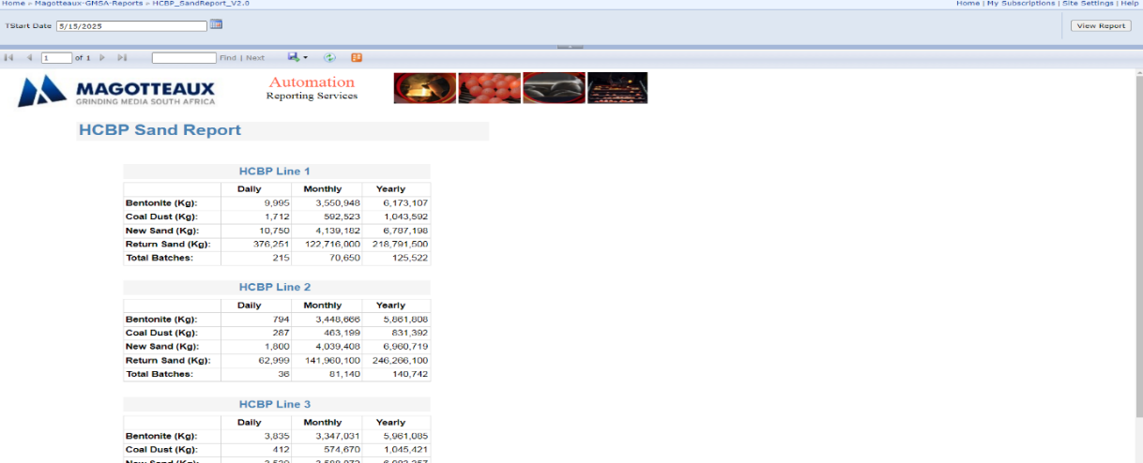
7.1.7 HCBP Heat Treatment Pushes Summary
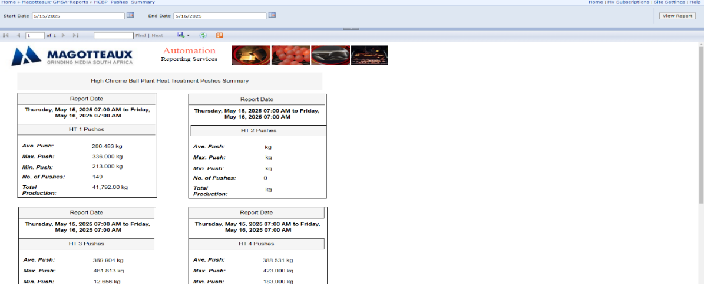

7.1.8 HCBP Line Summary Report
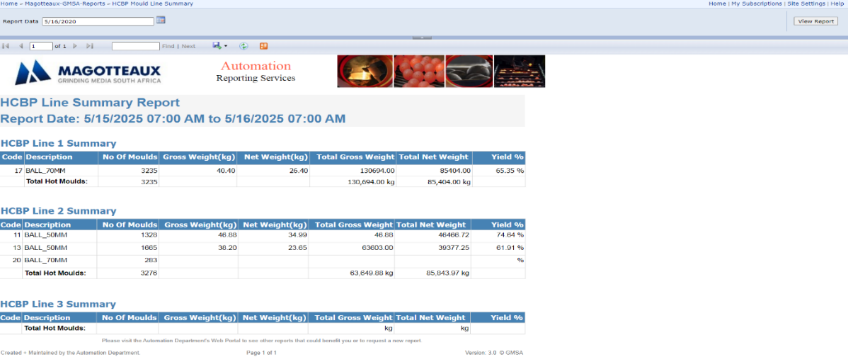

7.1.9 HCBP Line 2 Heat Mould Report
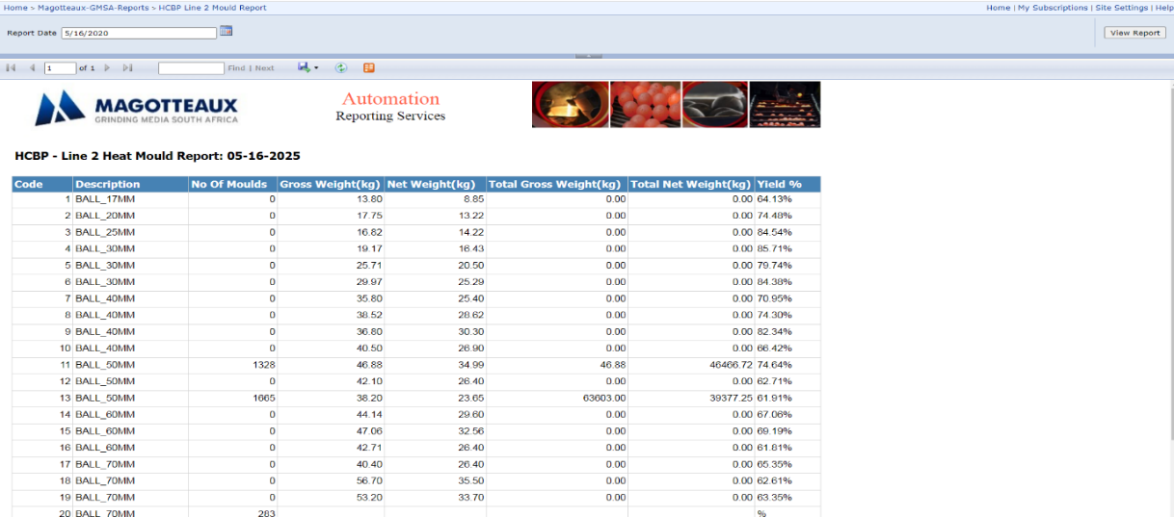
7.1.10 HCBP Line Summary Report
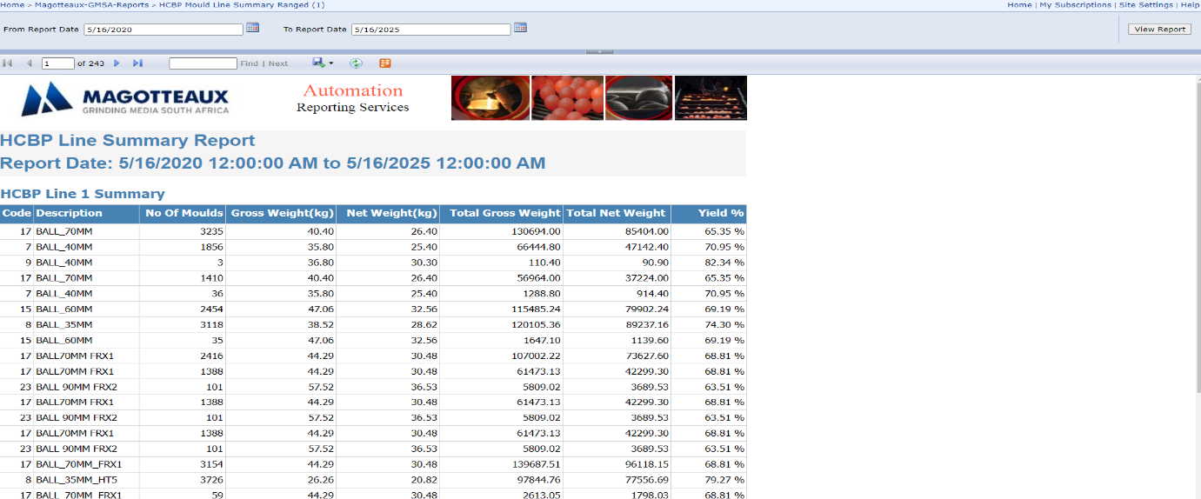

7.1.11 HCBP Line 1 Heat Mould Report
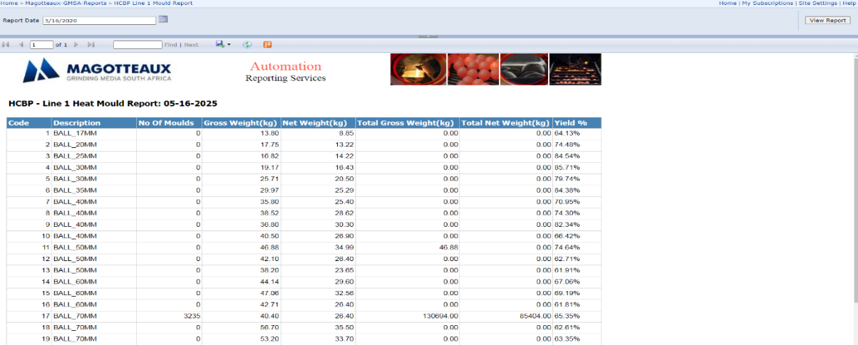

7.1.12 HCBP Line Summary Report
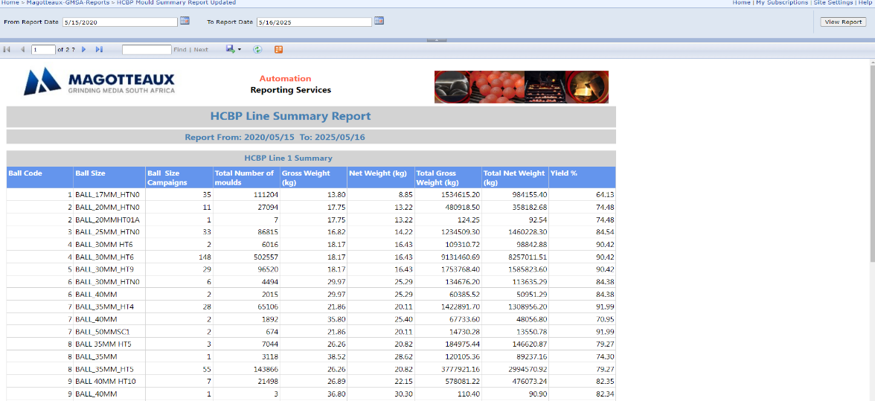
7.1.13 HCBP Heat Treatment 3 Pushes
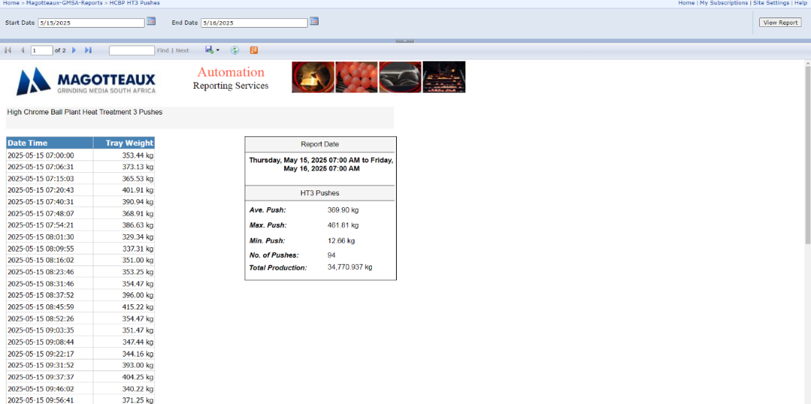

7.1.14 HCBP Line 3 Heat Mould Report
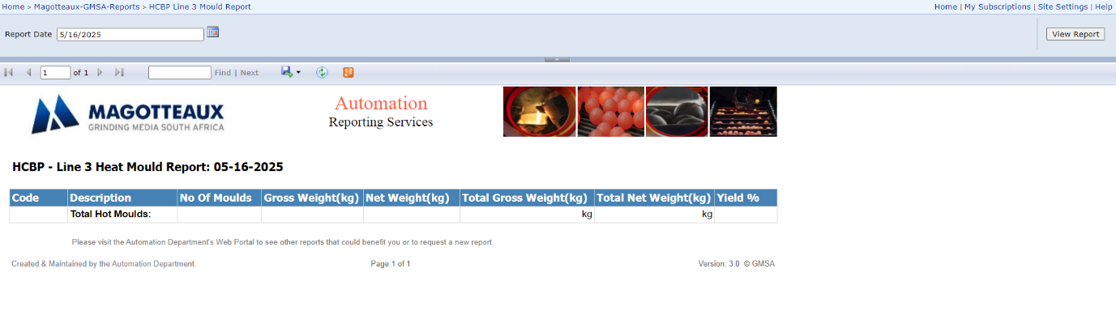

7.1.15 Grinding Media Power Consumption
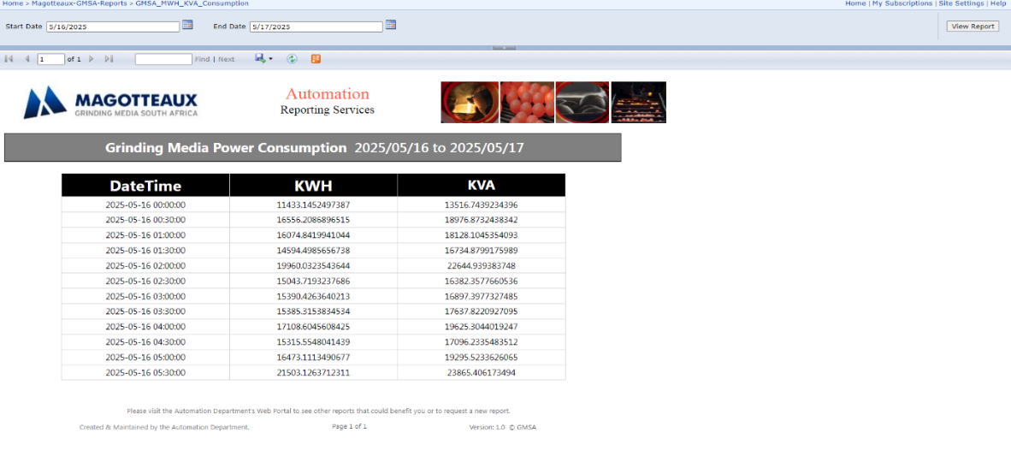
7.1.16 HCBP Daily Production Summary Report
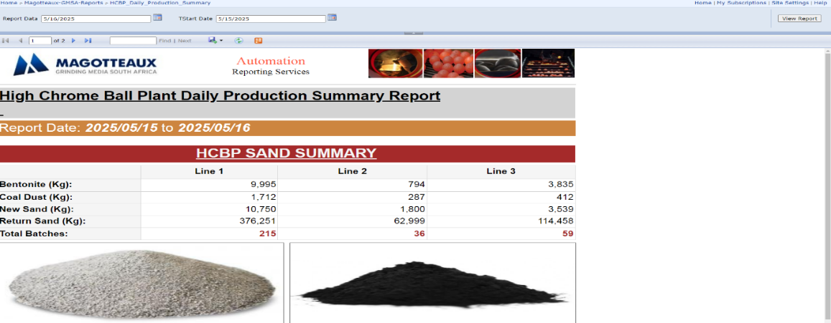

7.1.17 HCBP Water Pressure Report
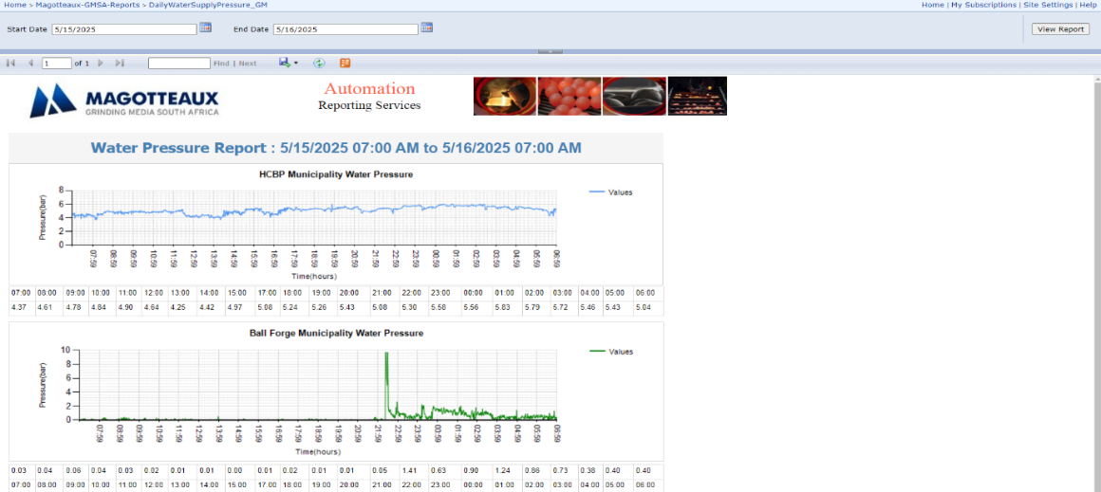

7.1.18 HCBP Daily Environmental Report
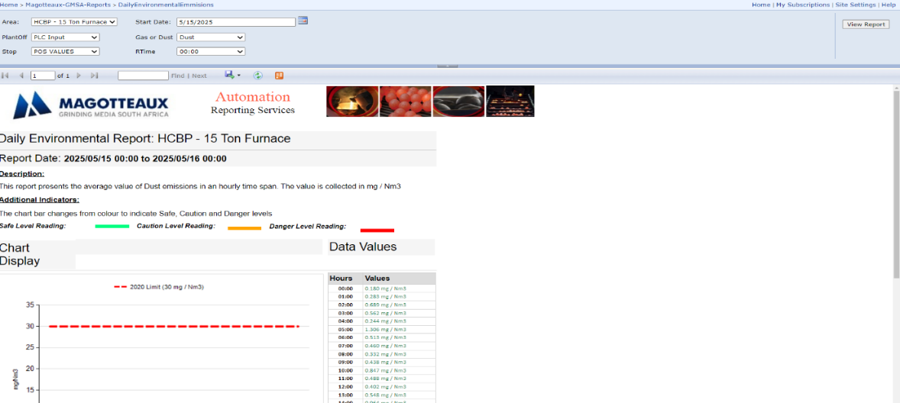
7.1.19 HCBP Heat Treatment 2 Pushes
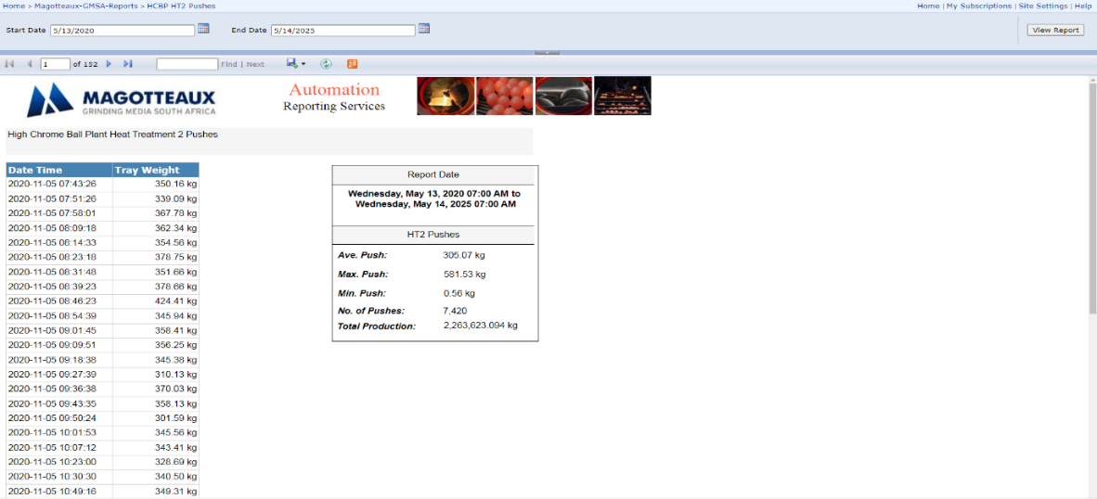

7.1.20 Ball Forge Ajax 2
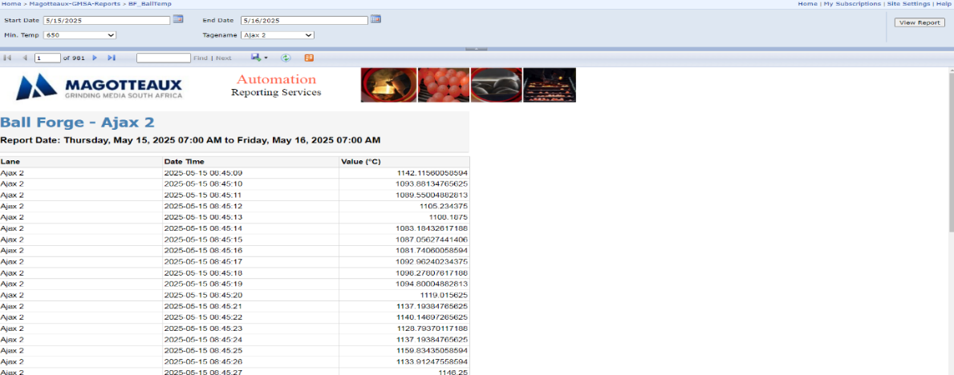

7.1.21 Monthly Cumulative Ball Forge Power Consumption Report
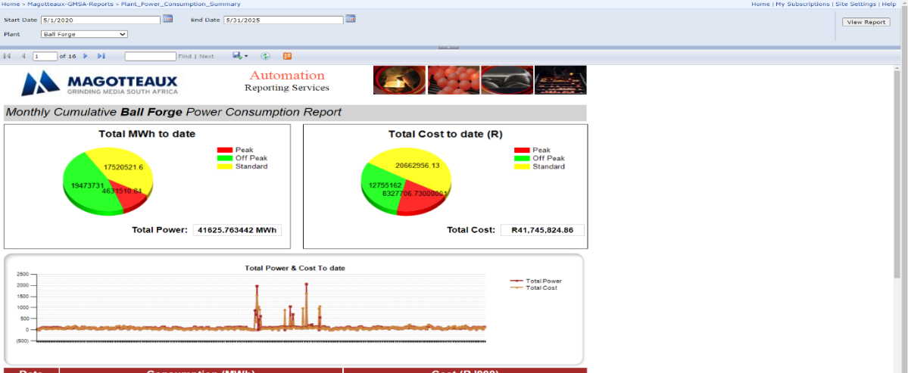
7.1.22 Ball Forge Howden Oven Temperature
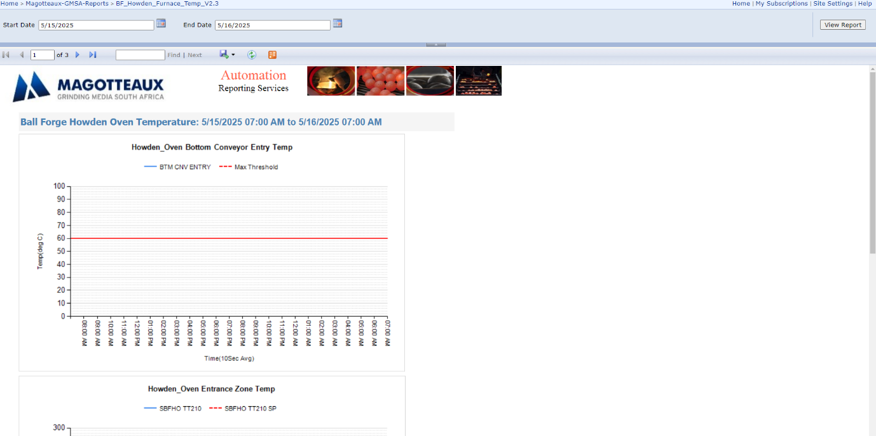

7.1.23 33KV
